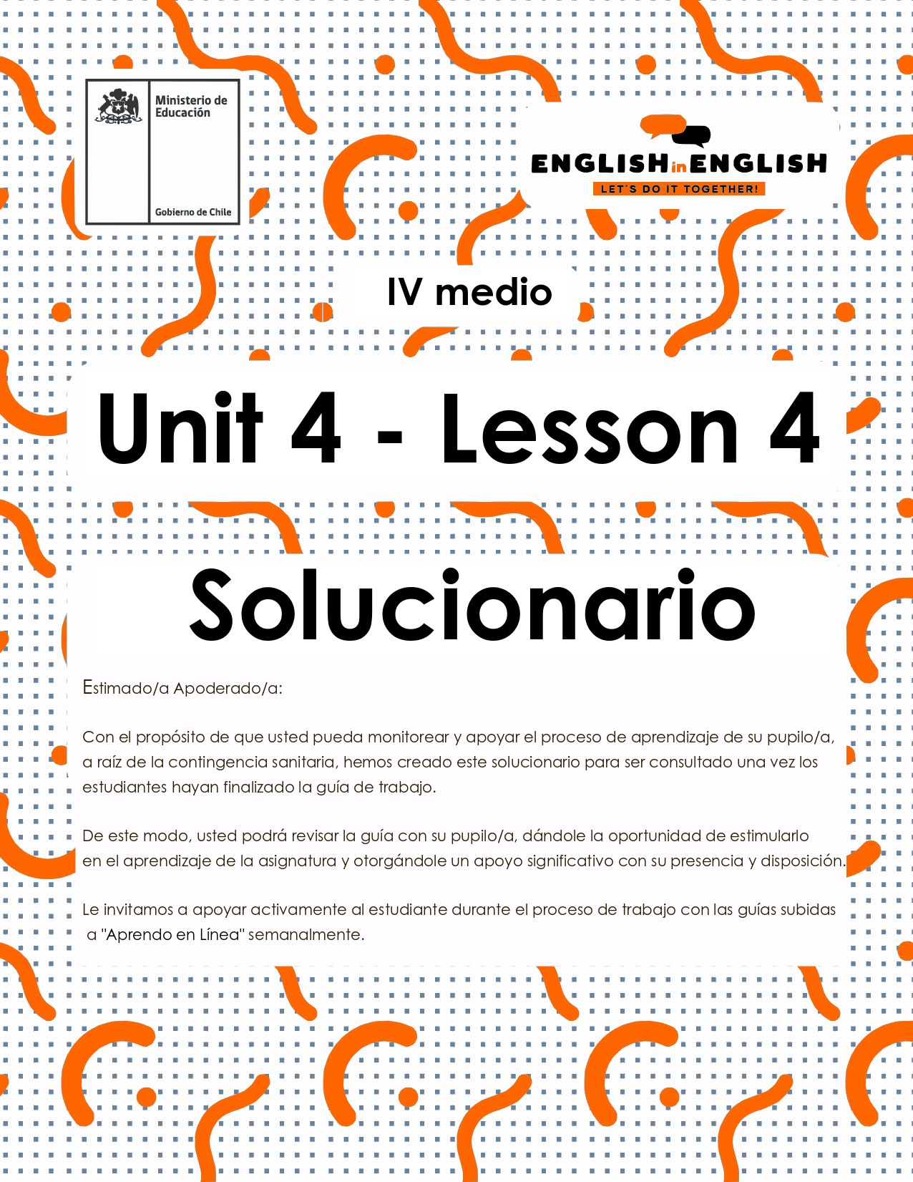

UNIT 4
LESSON 4

GUÍA PARA USAR EL SOLUCIONARIO
¿Qué es un solucionario?
- Un solucionario incluye las respuestas a todas las preguntas y actividades.
- Algunas de las preguntas tienen más de una posible respuesta.
- Algunas de las preguntas tienen una sola respuesta.

- ¿Cómo revisar mis respuestas?
- Encontrarás títulos en los encabezados de los ejercicios que dicen “answers” en respuestas cerradas, y en el caso de respuestas abiertas encontraras un encabezado indicando “answers may vary”.

- Las respuestas en ejercicios de verdadero falso, llenado de tablas, unión de letras y dibujos, etc. pueden estar en:
- Negrita
- Subrayado
- Sombreado con colores de formato de guía (purpura, verde, naranjo)
- Encerradas en círculos
red
- Destacadas
- Tachadas

- Ejemplos de respuestas se ilustran a continuación:
I) What is the first thing you think of when you look at it? Why?
Answers may vary.
Example: Art, music, painting. Because there are different people doing these activities.

II) Find the words to complete the sentences using the picture clues. For extra help you can use the Pictionary at the end.

a. The artists used materials like rubber, plaster and styrofoam to make their art.
b. Pomaire pottery is mainly made of clay. Don´t forget to visit this magical village!

SECTION 1: SETTING THE CONTEXT

Hello Students, welcome back to lesson 4. In this lesson we will review the key vocabulary, grammar and functions from the unit to work on our final project and create an original, creative and innovative gadget.
- Look at the following collage with pictures from the unit and answer the following questions.
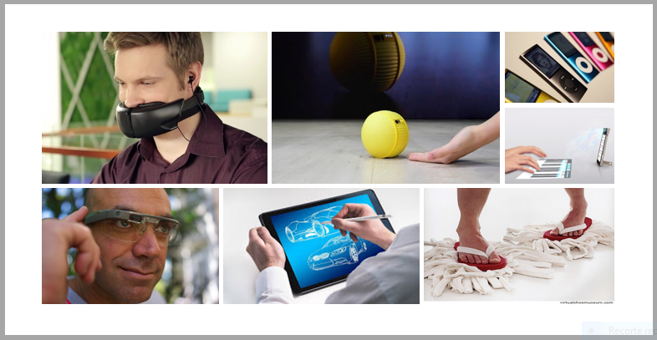
Answers may vary
a) What makes a good gadget?
A good gadget should be cheap, useful and available at all markets.

b) Why some gadgets were not successful?
Because they were too expensive, or their quality was low.

C) Would you use any of these gadgets? Why/why not?
Yes, I would. I love using new things in my daily routine.
No, I would not. I prefer using the old ones.

D) Can you name 3 features of a successful gadget?
- Good price 2. High performance. 2. Easy to be used by people of all ages.

E) Can you describe your ideal gadget?
One that could be easy to use, charge and find.

- Marco and Fabiola from Venezuela and Chile are creating a new gadget for their IT class. They have noted down some ideas, but they have not sketched the design yet. Can you help them?
Answers may vary
Marco and Fabiola | Notes and ideas
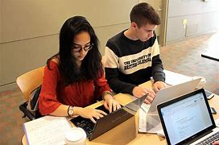 | It’s educational.  You can listen to music on it.  You can watch movies on it.  It’s a good way to stay in contact.  You can play games on it.  It’s small and easy to carry.  You can tell the time with it.  It’s useful in emergencies.  You can take photos with it.  You can save information on it.

Sketch your idea to help them HERE!

Answers may vary

SECTION 2: LET’S PRACTICE
- Look at the pictures and classify them into the four categories
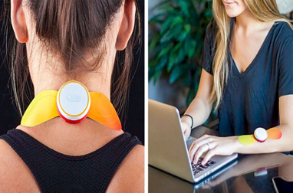 | 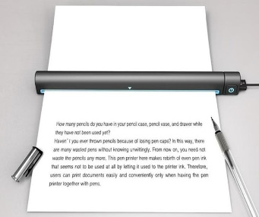 | 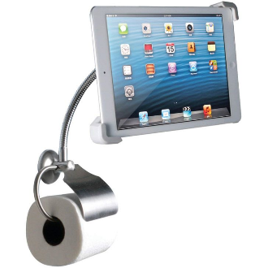
Device for relieving pain | The pen printer | A stand for the tablet
 | 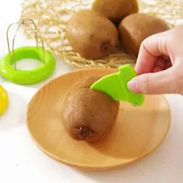 | 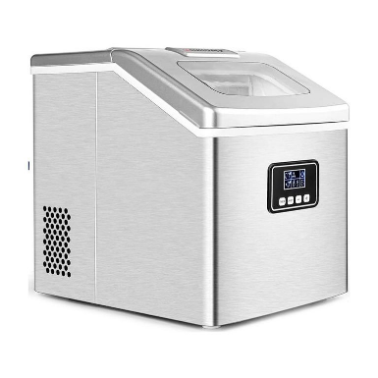
Selfie shoe | Fruit and vegetable cutter | Ice maker
Adapted from https://brightside.me/creativity-design/22-tech-gadgets-our-grandchildren-may-be-using-in-the-future-548660/
Answers may vary
For leisure | For studying | For cooking | For personal care
Selfie shoe | A pen printer | Ice maker | Device for relieving pain
A stand for the toiler | Device for relieving pain | Fruit or vegetable cutter

- Read the following sentences and say if you agree (A) or disagree (D). What do you think will happen with gadgets in 50 more years?
Answers may vary

- ___F___In the future, people will live without electronic gadgets.
- ___F___All gadgets will use solar energy to work.
- ___F___Gadget will replace all human duties.
- ___T___Some gadgets like the ones for smartphones and the Internet are paving the way for the future.
- ___T__Thanks to the implementation of eco-friendly gadgets, environmental pollution will end.

- Choose two statements from the previous exercise and complete the sentences.
Answers may vary

- I agree with sentence_E_ because technology will end up polluting systems and machines.
- I disagree with sentence_A__because most gadgets will need electricity to work.

SECTION 3: LET´S CONSTRUCT AND APPLY OUR KNOWLEDGE

- For this week final project, we invite you to create a new, innovative, original and useful gadget that represents your needs for the future. For this:
- Make a list of positive gadgets features:
Answers may vary

- Beautiful  - Cheap  - Available  - With wireless  - fun  - light | - Colorful  - Recyclable  - pocket size  - easy to charge  - soft  - bright

- Choose five of these features and decide the area of your gadget. You can choose from these categories;
- Technology
- Kitchenware
- Bathroom ware
- Leisure
- Personal care
- For studies
- For pets
Other ______________________

- Write a brief description of your gadget by using this template
My gadget creation is in the area of leisure. I think my gadget is beautiful, colorful, fun. This gadget can be used for reading at night. In addition, this garget has a convenient price of 20 Pounds and includes headphones and car appliances.

- Make a drawing of your gadget or find a picture on the web that illustrate your idea
Drawing or picture here!
Answers may vary

SECTION 4: Extra activity

7.-Technology advances rapidly every day. New gadgets are created every hour. What do you think the following were made for?
Answers may vary

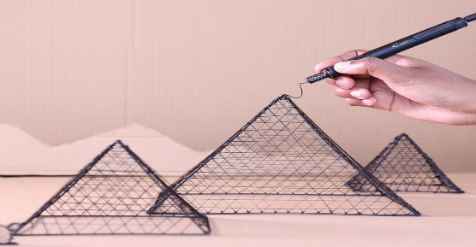 | To draw and design thanks to a #D pen.
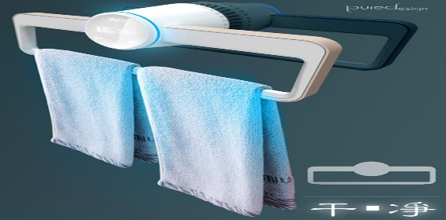 | Sanitize towels in a very short period of time.
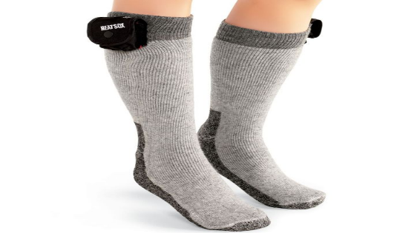 | Smart socks for diabetic people.

Adapted from https://brightside.me/creativity-design/22-tech-gadgets-our-grandchildren-may-be-using-in-the-future-548660/

