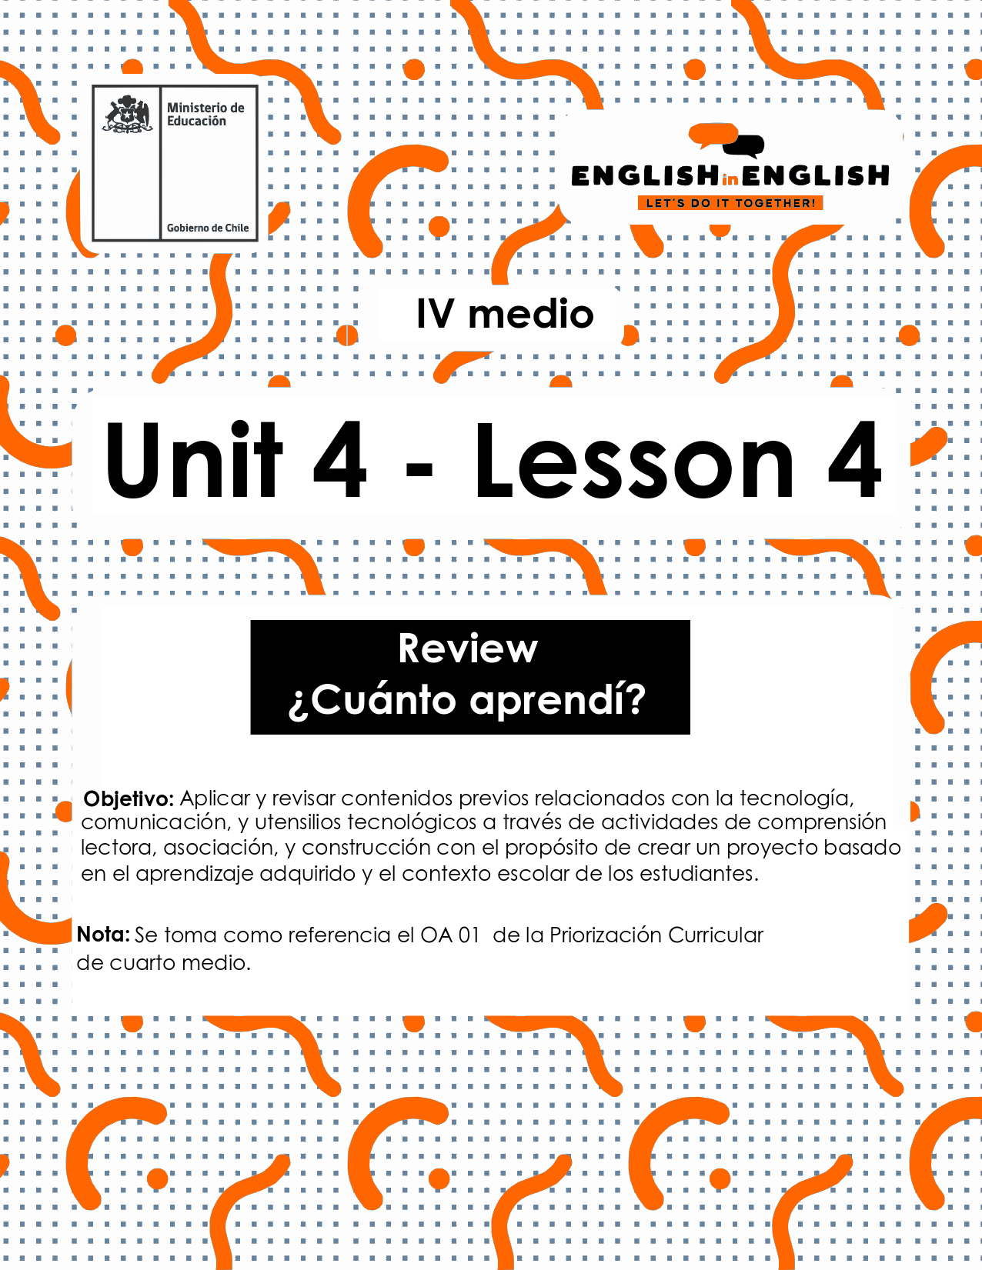

UNIT 4
LESSON 4

ÚTILES

- Texto del estudiante de 4° medio.
- Diccionario de inglés.
- Lápices.
- Cuaderno de asignatura.

SECTION 1: SETTING THE CONTEXT

Hello Students, welcome back to lesson 4. In this lesson we will review the key vocabulary, grammar and functions from the unit to work on our final project and create an original, creative and innovative gadget.
- Look at the following collage with pictures from the unit and answer the following questions.
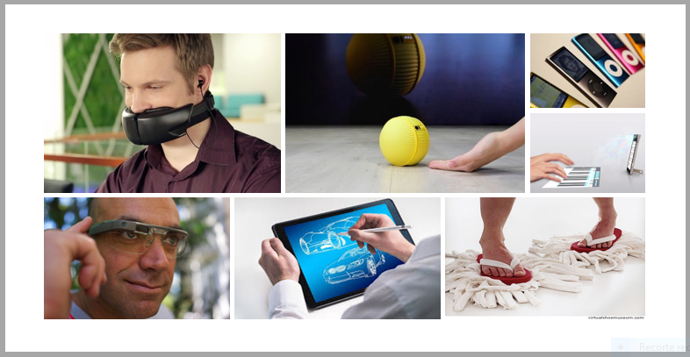
a) What makes a good gadget?

b) Why some gadgets were not successful?

C) Would you use any of these gadgets? Why/why not?

D) Can you name 3 features of a successful gadget?

E) Can you describe your ideal gadget?

- Marco and Fabiola from Venezuela and Chile are creating a new gadget for their IT class. They have noted down some ideas, but they have not sketched the design yet. Can you help them?
Marco and Fabiola | Notes and ideas
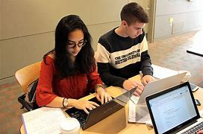 | It’s educational.  You can listen to music on it.  You can watch movies on it.  It’s a good way to stay in contact.  You can play games on it.  It’s small and easy to carry.  You can tell the time with it.  It’s useful in emergencies.  You can take photos with it.  You can save information on it.

Sketch your idea to help them HERE!

SECTION 2: LET’S PRACTICE
- Look at the pictures and classify them into the four categories
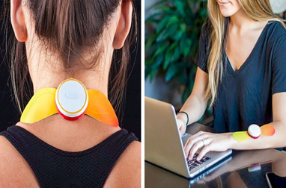 | 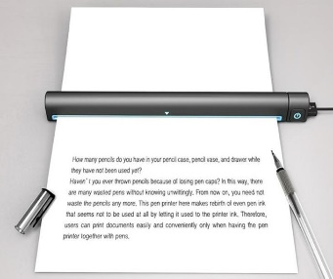 | 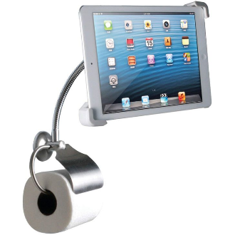
Device for relieving pain | The pen printer | A stand for the tablet
 | 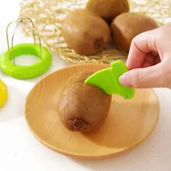 | 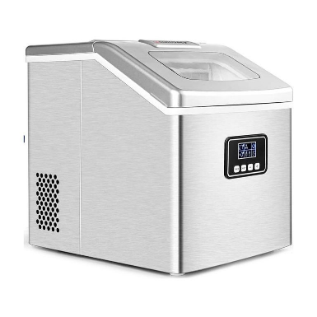
Selfie shoe | Fruit and vegetable cutter | Ice maker
Adapted from https://brightside.me/creativity-design/22-tech-gadgets-our-grandchildren-may-be-using-in-the-future-548660/

For leisure | For studying | For cooking | For personal care
Selfie shoe

- Read the following sentences and say if you agree (A) or disagree (D). What do you think will happen with gadgets in 50 more years?

- ______In the future, people will live without electronic gadgets.
- ______All gadgets will use solar energy to work.
- ______Gadget will replace all human duties.
- ______Some gadgets like the ones for smartphones and the Internet are paving the way for the future.
- _____Thanks to the implementation of eco-friendly gadgets, environmental pollution will end.

- Choose two statements from the previous exercise and complete the sentences.
Answers may vary

- I agree with sentence___ because._________________________________________
- I disagree with sentence___because.______________________________________

SECTION 3: LET´S CONSTRUCT AND APPLY OUR KNOWLEDGE

- For this week final project, we invite you to create a new, innovative, original and useful gadget that represents your needs for the future. For this:
- Make a list of positive gadgets features:

- Beautiful | - Colorful

- Choose five of these features and decide the area of your gadget. You can choose from these categories;
- Technology
- Kitchenware
- Bathroom ware
- Leisure
- Personal care
- For studies
- For pets
Other ______________________

- Write a brief description of your gadget by using this template
My gadget creation is in the area of ________. I think my gadget is beautiful, colorful, fun. This gadget can be used for ______________. In addition, this garget has a convenient price of _____________and includes _________ and ______appliances.

- Make a drawing of your gadget or find a picture on the web that illustrate your idea
Drawing or picture here!

SECTION 4: Extra activity

7.-Technology advances rapidly every day. New gadgets are created every hour. What do you think the following were made for?

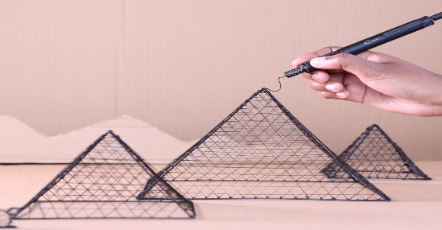
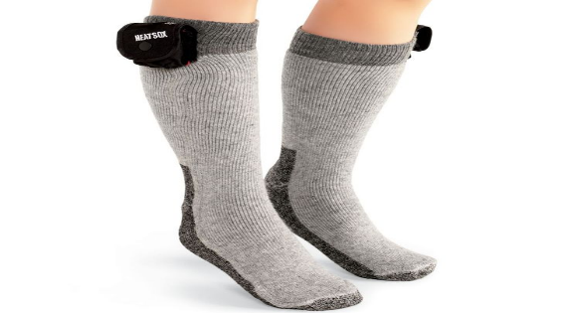

Adapted from https://brightside.me/creativity-design/22-tech-gadgets-our-grandchildren-may-be-using-in-the-future-548660/

