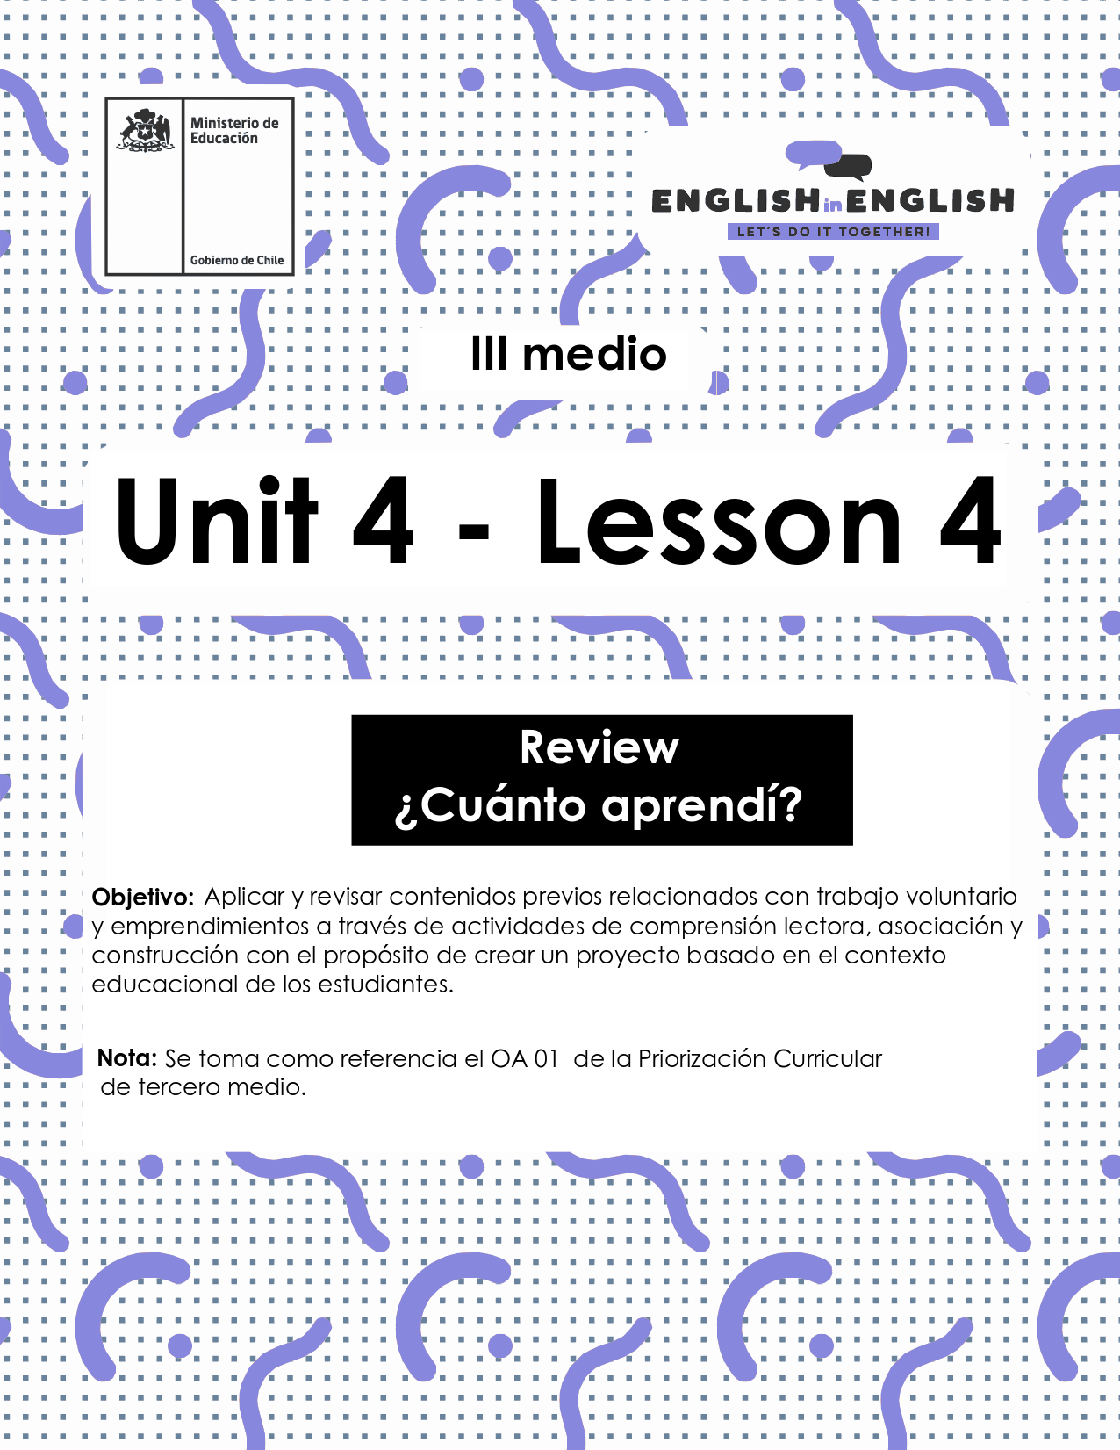

UNIT 4
LESSON 4

ÚTILES

- Texto del estudiante de 3° medio.
- Diccionario de inglés.
- Lápices.
- Cuaderno de asignatura.

SECTION 1: SETTING THE CONTEXT

Hello Students, welcome back to lesson 4. In this lesson we will review the contexts and activities from this unit to create a final project about volunteer work.
- Look at the following collage with pictures from the unit and answer the questions.
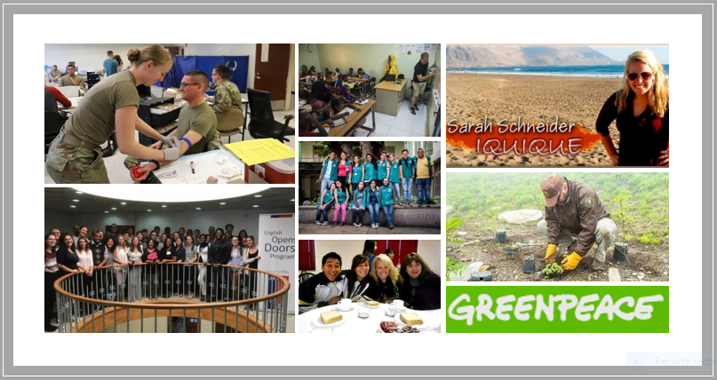
- Can you name 2 organizations supporting volunteer work internationally?

- Can you name two different purposes of volunteer work?

- Can you name at least 5 activities promoted in volunteer work?

- Can you name and briefly describe a volunteer programme carried out in Chilean schools?

- What are your impressions of volunteer work now compared to three weeks ago?

- Describe the activities these volunteers are doing. Use the words given.
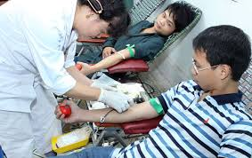 | Example:  My friends Qiang and Jian from China volunteered to donate blood last summer.  Donate- China-Blood
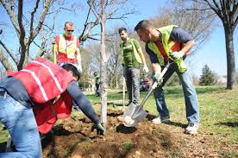 | Trees-Forest-planting
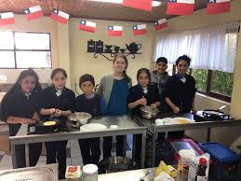 | Volunteered- schools- Chilean
 | Went-climate- experience

- Name two activities volunteers could do to help others in education.

SECTION 2: LET´S PRACTICE

- Having a strong and convincing motto is essential for captivating volunteers and promoting your programme. Read these strong and captivating mottoes and answer the question bellow.

- 1 Year = 365 Opportunities.
- Be a Part of Something Bigger than Yourself.
- Do Small Things with Great Love.
- Doing Good Does You Good.
- If You See a Need, Take the Lead.
- Kindness like a boomerang, always returns.
- Volunteers are love in motion!
- Volunteers are paid in six figures… S-M-I-L-E-S.
- Volunteers do not necessarily have the time; they have the heart.
Adapted from https://brandongaille.com/list-45-catchy-volunteer-campaign-slogans/

  - Why are these mottoes strong and convincing?

  - Which one is your favourite? Why?

  - Which one is your less favourite? Why?

- Mottoes are a powerful way to motivate and promote a good cause. Can you say what the following ones means to you? Please explain.
  - “Dare to share!”_________________________________________.
  - “Sharing is caring.” ________________________________________.
  - “One person can make a difference.” ______________________________.
  - “Be like the sun and you shall warm the earth.” _____________________________________________________________
6. Advertising your volunteer programme is one of the keys for success in your mission. Read the following text with ideas to promote a marketing strategy for your programme, then, do the activities below.
Top ideas to promote your volunteer programme
A strong volunteer program marketing strategy is crucial for the success of your idea. The volunteers in your community provide the hands that do the work, whether you or your organization is focused on feeding the hungry, elderly protection, cleaning up a park, or caring for animals. One of the most important components of your volunteer management strategy is marketing your volunteer program to those who haven’t yet become involved. Your marketing strategy is responsible for finding individuals who could become valuable members of your community, so it’s imperative that you get it right.
In order to help your volunteer programme, take advantage of this trend and step up your marketing strategy, we provide a list of our favourite communication ideas to help your organization find more people and push your mission even further. Those ideas are:
- Create a program that people want to be involved in.
- Emphasize the impact that volunteers have.
- Identify and advertise what your non-profit needs.
- Reach out to people who are already involved in your non-profit program.
- Be active.
Adapted from https://www.volunteerhub.com/blog/marketing-your-volunteer-program-6-keys-to-total-success/
  - Find in the text a word with a similar meaning
Answers may vary
Word | Similar meaning | word | Similar meaning
Old |  | Participants
Important |  | Support
Give |  | Highlight

  - Complete the following chart with information from the text
Answers may vary
Write 3 activities involved in volunteer work:
Write the objective of a marketing strategy is:
Write an extra idea to promote volunteer work.

SECTION 3: LET´S CONSTRUCT AND APPLY OUR KNOWLEDGE.

7.- Last week, you created a volunteer programme overview that included activities, objectives, a motto, resources to be used, people and sponsors involved, etc. For this week final project your goal is to promote your programme to the Chilean government, so you can get support.
A.- Complete the summarized template of your programme to help organize your ideas.
(We are always by your side)
Area of volunteer programme
Objective
Logo and Motto of the programme
Key activity
Description

Resources needed

B.- Select a means for adverting your programme. It can be a radio jingle, a TV ad, a Newspaper or magazine, a Billboard, street ads, etc,

C.- Write a short informative paragraph for your advertising to be presented to the Chilean government. Use the following template
Advertising
The main objective of my volunteer programme is to ___________________This is important___________________________. I will promote the volunteer programme in the radio. I think __________________________________________________

D.- Create the advertising by using photos, different and original fonts, colours and do not forget to include your motto.
F.- Sell it!

SECTION 4: SPONGE ACTIVITY
8. look at these two posters that promoted events for raising money in Chile.
Adapted from Get Real textbook

Could you volunteer to participate in any of these events? Why? Why not?

