UNIT 2
LESSON 3

ÚTILES

- Texto del estudiante de 4° medio.
- Diccionario de inglés.
- Lápices.
- Cuaderno de asignatura.
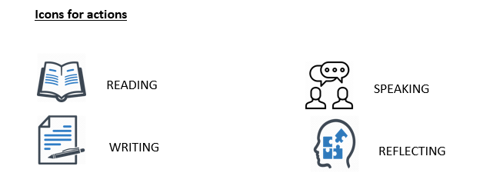

SECTION 1: SETTING THE CONTEXT

Welcome to lesson number 3! Now it’s time to practice some Writing skills! Let´s begin with the following exercises:
- Look at the following pictures and write the corresponding WH question.
________is the supermarket? | _______ Is that? | _________ Is the meeting?
____ are you so angry? ________ money do you want?

2. We use WH-questions to find out more information every time a question cannot be answered with “yes” or “no”.
Complete the following dialogue with Wh-question from the box:

WHAT – HOW – WHICH – WHY- WHERE

Journalist: _______ one is your family name?
Elena: It is Astudillo
Journalist: ________ do you do?
Elena: I am a painter.
Journalist: _________ do you work?
Elena: At St Mary´s Art Gallery.
Journalist: ________ long have you work there?
Elena: For three years.
Journalist: __________do you work there?
Elena: Because it is my family´s business.
Journalist: Thanks Ms Astudillo! Please don´t forget to send me a short email telling more things about yourself as soon as possible. Goodbye!
Elena: Goodbye!

2.1 Later, Elena starts writing the email telling about herself.
- Read the information below and rewrite the sentences using the words in brackets.
- Use the underline ones as a clue.
- Do not forget to pay attention to tenses:

Well, I have always believed arts is in my blood. Instead of playing with friends or watching cartoons, since I was a little girl, I started spending long hours drawing, painting or doing whatever possible to express my feelings and emotions trough songs, textures or colours. During school time, it was very difficult for me to concentrate on Maths or Chemistry lessons as the only thing I wanted to do was use palettes, clay or crayons. Art classes were a blast! I cannot say the same for History or ICT lessons. As years went by, I told my parents I wanted to dedicate my life to arts. Since that day, mom and dad are my biggest fans!

- Since she was a child, Elena has always devoted her life making art projects. (enjoy)

- At school, it was hard for her to attend lessons like Math or Chemistry. (can´t stand)

- Attending art classes made her very happy. (love)

- Elena´s parents agree with what she does for a living. (like)

.
SECTION 2: LET’S PRACTICE!
3. Look at the following collage and complete the sentences with your personal preferences about art.
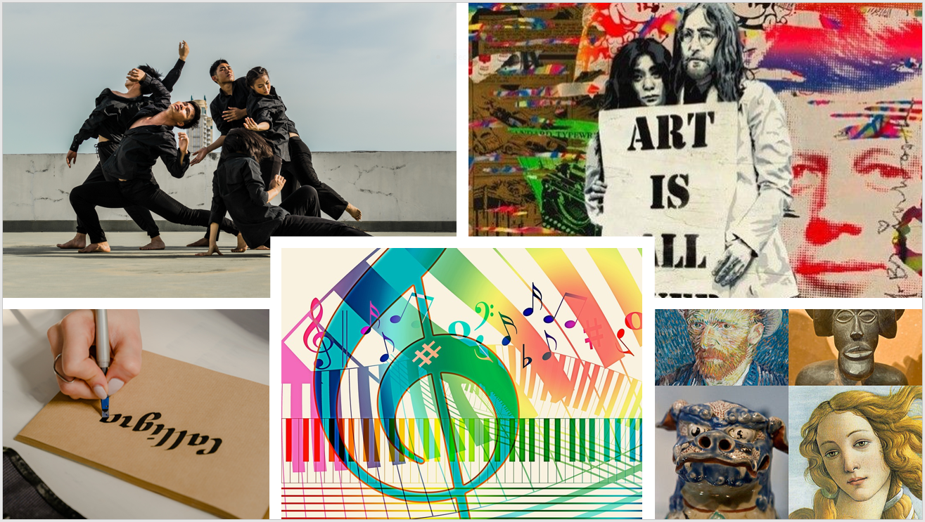
- I love ___________
- I hate____________
- I enjoy_________
- I like ________
- I don`t Like ____
4. Complete the concept map with your ideas about art.
- Then, complete a text message explaining why you like art or not. 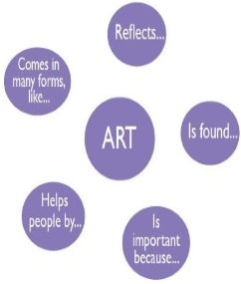
From:
To:
Hello ________! I hope you are ok. I am writing to tell you about arts. Well, for me art reflects _______. Art is everywhere. For example, Art is found_______. Art is important because ________, and Art also helps people by_________. In conclusion, Art comes in many forms, like __________.
That’s all,
Bye_________

SECTION 3: LET´S CONSTRUCT AND APPLY OUR KNOWLEDGE

5. Let´s check your general knowledge about graffiti and street art now!
- Read the following Biography and look at these famous graffiti from the iconic and incognito artist Bansky from England.
- Then answer the questions below:

Banksy is an anonymous England-based street artist, political activist, and film director. His satirical street art and subversive epigrams combine dark humor with graffiti executed in a distinctive stencilling technique. His works of political and social commentary have been featured on streets, walls and bridges throughout the world. Banksy's work is sensitive and shows a combination of feelings that convey irony, love, poverty, passion and reality. In these two graffiti we can see an adaptation of the girl with a pearl earring wearing a surgical mask, and a little girl leaving her balloon shaped heart away.
Adapted from https://es.wikipedia.org/wiki/Banksy

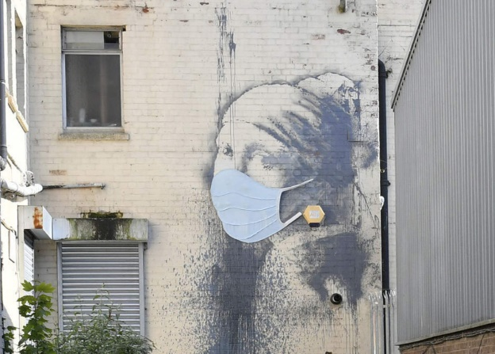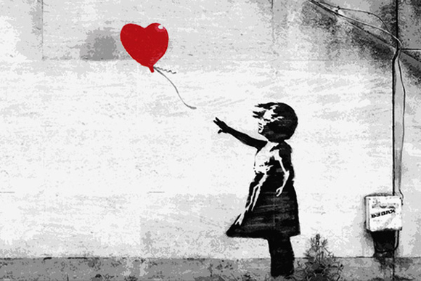

- What is happening in these pieces of street art?

- How do they make you feel?

- Which of these pieces of street art is your favourite?

- Why?

- Where could you find this type of graffiti or street art in your city?

6. Now we would like to know about your city or community.
- - Is there a piece of street art that you would like to tell us about?
- - For example, the big graffiti and open sky museum in Valparaíso, or the Gabriela Mistral murals in Vicuña.
- - Choose one piece of graffiti or street art from your city or community and tell us:
- The name (if you know it)
- Where it is
- What is happening in the art piece?
- What makes you feel
- Why you chose it
- Put a photo if you have one!

6.1 Write a short paragraph with the information.
- You can follow the text from Bansky Biography as an example.
________________________________________________________________________________________________________________________________________________________________________________________________________________________________________________

SECTION 4: EXTRA ACTIVITY

7. It is time you use all your creativity!
- What about designing or making your own art manifestation?
- What would you do?
- What for?
- What kind of materials would you use?
- Tell us about it!
- You can start writing following this example:

I think I would make a sculpture related to my neighbourhood background. I love history and observing local traditions. I have always liked my community and the way my neighbours have faced difficulties and bad times. Although everybody here enjoys celebrating good news; nobody can´t stand abuses or mistreats. So, the name of my piece of art would be “4people- 2people.”
About materials, I would work with stones and wood because most houses here have been built with them and...

______________________________________________________________________________________________________________________________________________________________________________________________________________________________________________________________________________________________________________________________________________________________

