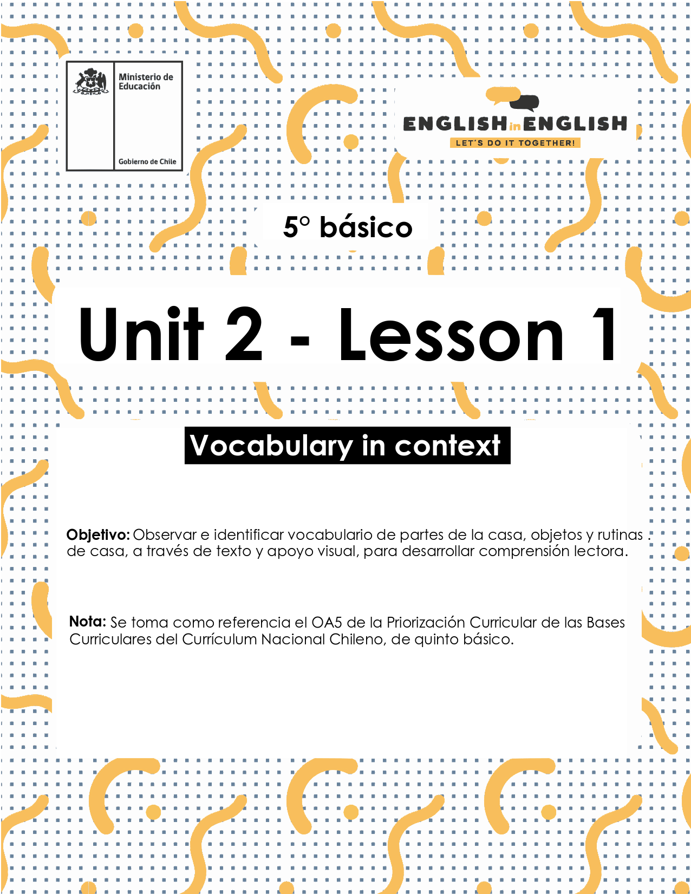

# UNIT 2 LESSON 1

## ÚTILES RECOMENDADOS:

* Texto del Estudiante 5° Básico
* Diccionario de Inglés físico / online <https://dictionary.cambridge.org/es/diccionario/espanol-ingles/>
* Cuaderno de inglés o 2 hojas en blanco.
* Lápiz grafito y goma.

## SECTION 1: SETTING THE CONTEXT

## “House vocabulary”

**1. Observe the image and answer the questions.**

* Observa la imagen con atención y responde las preguntas.

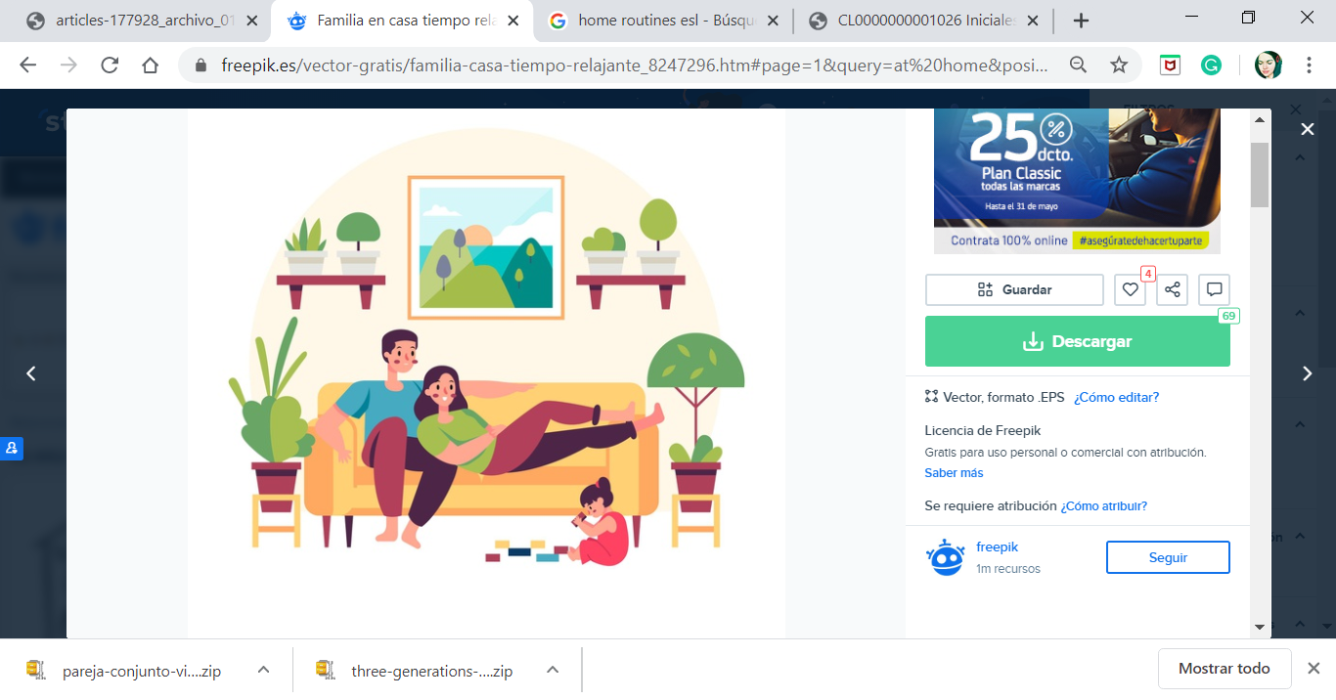

**Where are they?**

* ¿Dónde están ellos?

___________________________________________________

**Think about some activities you do at home.**

* Piensa en algunas actividades que haces en casa.

___________________________________________________

**2. Observe the images and the vocabulary.**

* Observa las imágenes y el vocabulario.

|  |  |  |
| --- | --- | --- |
| **Parts of the house.** | | |
| Bedroom | Kitchen | Living Room |
| Bathroom | Dining Room | Garden |

|  |  |  |
| --- | --- | --- |
| **Home Routines.** | | |
| Tidy my bedroom | Do my homework | Do the dishes |
| Work on the computer | Watch TV | Chat with friends |

|  |  |  |
| --- | --- | --- |
| **House Objects.** | | |
| Bed | Shower | Couch |
| Table and chairs | Fridge | Plants |

## SECTION 2: LET'S PRACTICE

## “Reading a text”

**1. Read the text. What is it about?**

* Lee el texto. ¿De qué se trata?

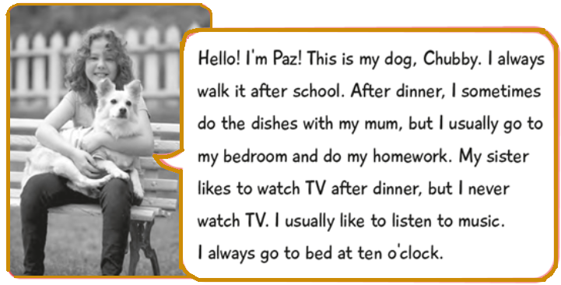

**2. Find the words from the vocabulary in the text and classify it.**

* Encuentra las palabras del vocabulario en el texto y clasifícalas.

|  |  |  |
| --- | --- | --- |
| Parts of the house | Objects of the house | Home routines |
|  |  |  |

## SECTION 3: LET’S CONSTRUCT AND APPLY OUR KNOWLEDGE

## “Using the house vocabulary”

**1. Write the sentence from the box that corresponds to each image.**

* Escribe la oración del recuadro que corresponde a cada imagen.

|  |  |  |  |
| --- | --- | --- | --- |
| *I do the dishes in the kitchen. - I work on my computer in the dining room. - I do my homework in the bedroom. - I watch TV in the living room.* | | | |
| 1.______________  _______________ | 2.______________  _______________ | 3.______________  _______________ | 4.______________  _______________ |

**2. Choose the correct alternative about the objects and the parts of the house.**

* Elige la alternativa correcta sobre objetos y partes de la casa.

|  |  |  |
| --- | --- | --- |
| **1. The shower is in the…**   1. bedroom 2. bathroom 3. living room | **2. The plants are in the…**   1. garden 2. bathroom 3. bedroom | **3. The couch is in the…**   1. kitchen 2. living room 3. garden |
| **4. The table and chairs are in the…**   1. bedroom 2. dining room 3. bathroom | **5. The fridge is in the…**   1. garden 2. kitchen 3. bedroom | **6. The bed is in the…**   1. living room 2. dining room 3. bedroom |

**3. Observe this house and draw at least 2 objects that correspond to each room.**

**Write the home routines that you do. Use the boxes.**

* Observa esta casa y dibuja al menos 2 objetos que correspondan a cada habitación.
* Escribe las rutinas del hogar que tú haces. Usa los recuadros.

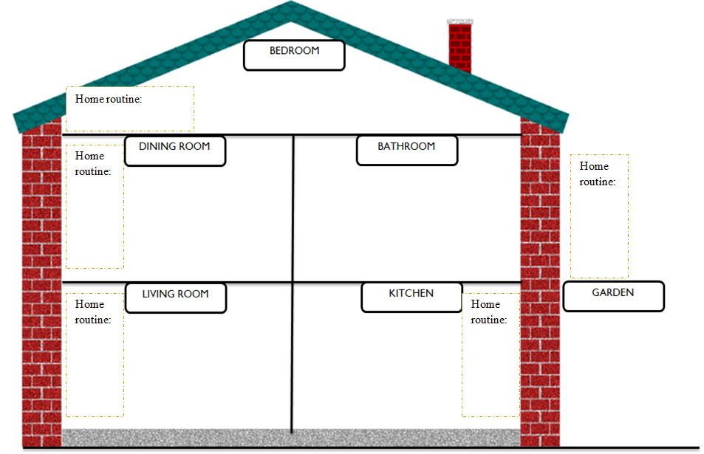

**4. Create a timetable of your home routines for the weekdays.**

**Use the vocabulary from “Home routine”**

* Crea un horario de tus rutinas del hogar para los días de la semana.
* Utiliza el vocabulario de “Home routine”
* Sigue el ejemplo.

|  |  |  |  |  |  |
| --- | --- | --- | --- | --- | --- |
| Feliz familia limpieza juntos ilustración plana vector gratuito  **HOME ROUTINE** | | | | | |
| Timetable | MONDAY | TUESDAY | WEDNESDAY | THURSDAY | FRIDAY | |
| MORNING | Do my homework |  |  |  |  | |
| AFTERNOON | Do the dishes |  |  |  |  | |
| EVENING | Chat with friends |  |  |  |  | |

## SECTION 4: SPONGE ACTIVITY

**Complete this chart about you!**

* ¡Completa este cuadro sobre ti!

|  |  |
| --- | --- |
| Name |  |
| Age |  |
| Grade |  |
| School |  |
| Family |  |
| Favorite part of the house |  |
| Most used object in the house |  |
| Favorite home routine |  |
| Home routine that you do with your family |  |

## NO OLVIDAR REPASAR EL CONTENIDO CON UN ADULTO