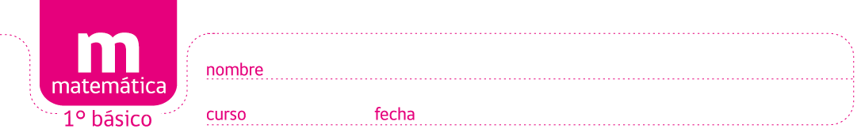

PAUTA ACTIVIDADES: EJERCICIOS DE CÁLCULO MENTAL

- Complete las siguientes tablas:
- | 1 |  | + | 1 |  | + | 0
7 | 6 |  | 13 | 14 |  | 20 | 20
11 | 10 |  | 2 | 3 |  | 12 | 12
13 | 12 |  | 4 | 5 |  | 5 | 5
9 | 8 |  | 10 | 11 |  | 8 | 8
18 | 17 |  | 18 | 19 |  | 14 | 14
20 | 19 |  | 13 | 14 |  | 17 | 17
10 | 9 |  | 17 | 18 |  | 13 | 13
5 | 4 |  | 19 | 20 |  | 11 | 11
8 | 7 |  | 5 | 6 |  | 9 | 9
14 | 13 |  | 16 | 17 |  | 16 | 16
16 | 15 |  | 1 | 2 |  | 18 | 18
12 | 11 |  | 0 | 1 |  | 10 | 10
4 | 3 |  | 7 | 8 |  | 8 | 8

- Completa los espacios vacíos:

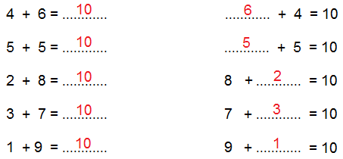

- Complete las siguientes tablas:

+ | 4 | 5 | 8 | 9
2 | 6 | 7 | 10 | 11
6 | 10 | 11 | 14 | 15
8 | 12 | 13 | 16 | 17
10 | 14 | 15 | 18 | 19
11 | 15 | 16 | 19 | 20

- | 3 | 4 | 8 | 10
10 | 7 | 6 | 2 | 0
18 | 15 | 14 | 10 | 8
15 | 12 | 11 | 7 | 5
17 | 14 | 13 | 9 | 7
20 | 17 | 16 | 12 | 10

Elaborado por: Ministerio de Educación de Chile

