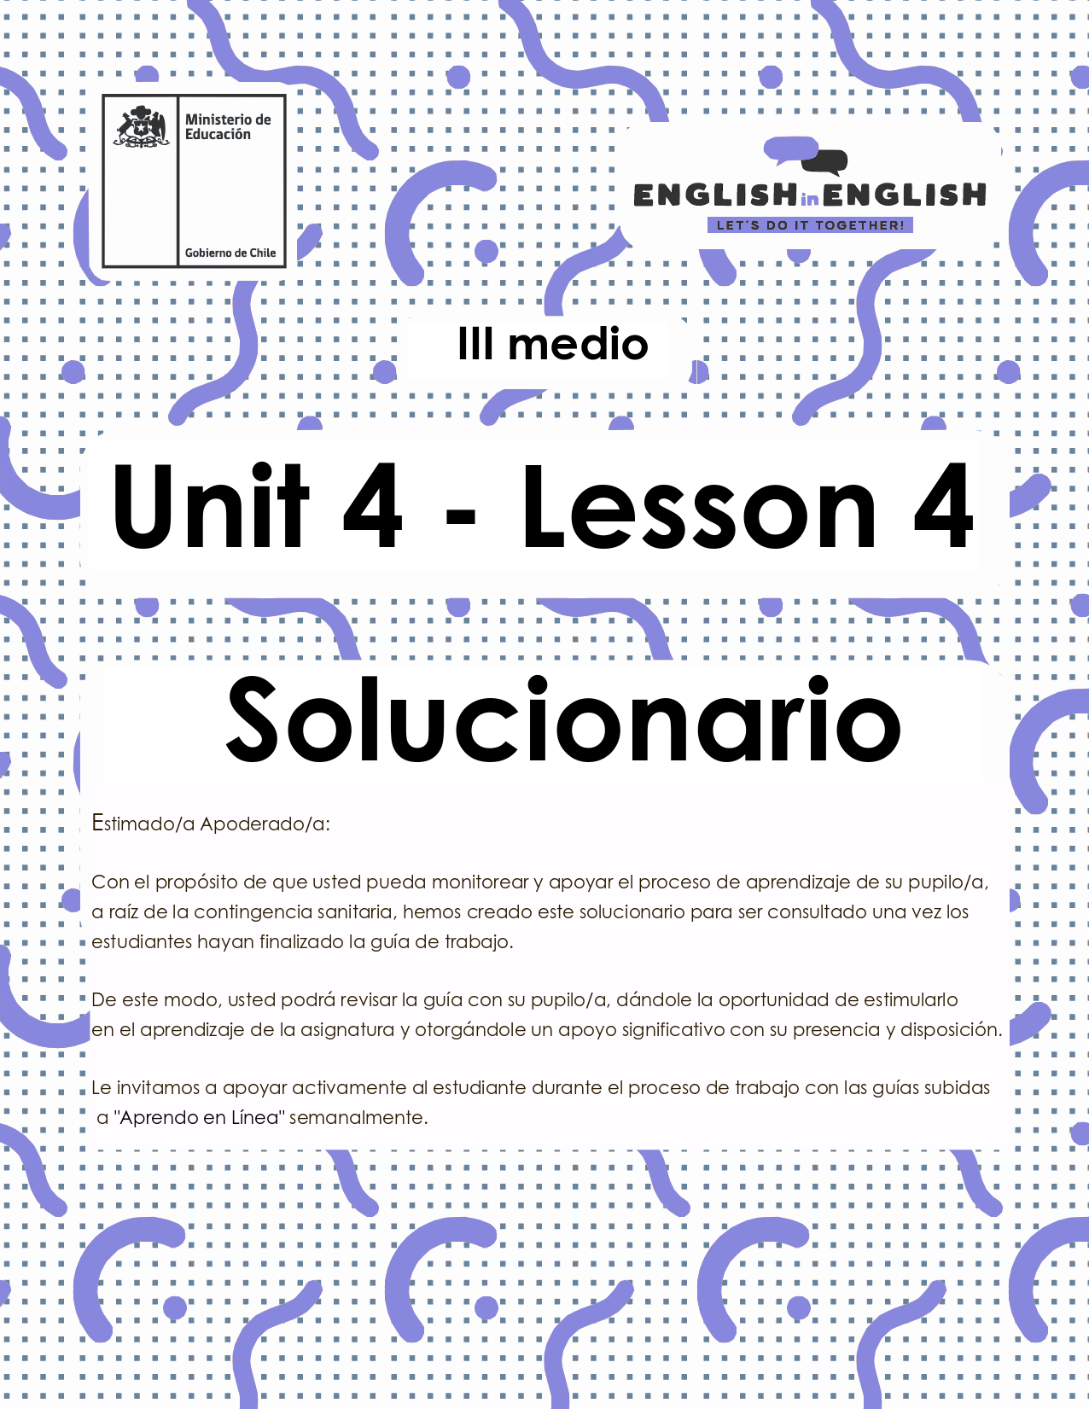
UNIDAD 4
LESSON 4

GUÍA PARA USAR EL SOLUCIONARIO
¿Qué es un solucionario?
- Un solucionario incluye las respuestas a todas las preguntas y actividades.
- Algunas de las preguntas tienen más de una posible respuesta.
- Algunas de las preguntas tienen una sola respuesta.

- ¿Cómo revisar mis respuestas?
- Encontrarás títulos en los encabezados de los ejercicios que dicen “answers” en respuestas cerradas, y en el caso de respuestas abiertas encontraras un encabezado indicando “answers may vary”.

- Las respuestas en ejercicios de verdadero falso, llenado de tablas, unión de letras y dibujos, etc. pueden estar en:
- Negrita
- Subrayado
- Sombreado con colores de formato de guía (purpura, verde, naranjo)
- Encerradas en círculos
red
- Destacadas
- Tachadas

- Ejemplos de respuestas se ilustran a continuación:
I) What is the first thing you think of when you look at it? Why?
Answers may vary.
Example: Art, music, painting. Because there are different people doing these activities.

II) Find the words to complete the sentences using the picture clues. For extra help you can use the Pictionary at the end.

a. The artists used materials like rubber, plaster and styrofoam to make their art.
b. Pomaire pottery is mainly made of clay. Don´t forget to visit this magical village!

SECTION 1: SETTING THE CONTEXT

Hello Students, welcome back to lesson 4. In this lesson we will review the contexts and activities from this unit to create a final project about volunteer work.
- Look at the following collage with pictures from the unit and answer the questions.
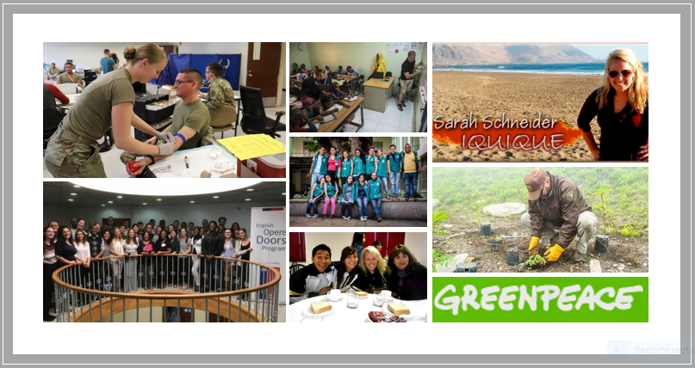
Answers may vary
- Can you name 2 organizations supporting volunteer work internationally?

Red Cross and Biodiversity Research Institute in the Tropical Forest of Brazil

- Can you name two different purposes of volunteer work?

To help save endangered species and strengthen education programs.

- Can you name at least 5 activities promoted in volunteer work?

  - Help poor people.
  - Build houses.
  - Heal the injured.
  - Save species.
  - Stop polluting the planet.

- Can you name and briefly describe a volunteer programme carried out in Chilean schools?

CNV: It is run by EODP. Volunteers help students and teachers to practise English.

- What are your impressions of volunteer work now compared to three weeks ago?

I think now that volunteer work is very important as it can make a difference in the society.

- Describe the activities these volunteers are doing. Use the words given.
Answers may vary
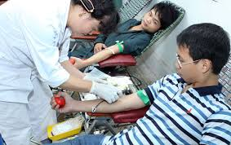 | Example:  My friends Qiang and Jian from China volunteered to donate blood last summer.  Donate- China-Blood
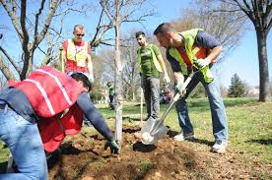 | Mike plated trees in the Amazon forest with Mario, Alejandro and Antonio  Trees-Forest-planting
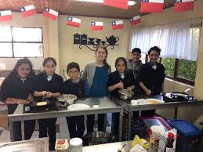 | Ursula volunteered to work in Chilean schools  Volunteered- schools- Chilean
I went to the Climate protest and it was a powerful experience

Went-climate- experience

- Name two activities volunteers could do to help others in education.
Answers may vary

I think they could do things like starting education programs or look for sponsors to let people know what they do.

SECTION 2: LET´S PRACTICE

- Having a strong and convincing motto is essential for captivating volunteers and promoting your programme. Read these strong and captivating mottoes and answer the question bellow.

- 1 Year = 365 Opportunities.
- Be a Part of Something Bigger than Yourself.
- Do Small Things with Great Love.
- Doing Good Does You Good.
- If You See a Need, Take the Lead.
- Kindness like a boomerang, always returns.
- Volunteers are love in motion!
- Volunteers are paid in six figures… S-M-I-L-E-S.
- Volunteers do not necessarily have the time; they have the heart.
Adapted from https://brandongaille.com/list-45-catchy-volunteer-campaign-slogans/
Answers may vary

  - Why are these mottoes strong and convincing?

I think they are strong and convincing because they are creative.

  - Which one is your favourite? Why?

I really liked the first one because it is a clever way to say that volunteering is needed everyday

  - Which one is your less favourite? Why?

Maybe, the third one is cliché

- Mottoes are a powerful way to motivate and promote a good cause. Can you say what the following ones means to you? Please explain.
Answers may vary
  - “Dare to share!” It means interacting with everybody everywhere.
  - “Sharing is caring.” Love and fraternity are expressions of love and sense of community.
  - “One person can make a difference.” Everybody can make a change even with small actions.
  - “Be like the sun and you shall warm the earth.” Helping and caring about people and all living beings can mean a lot.

6. Advertising your volunteer programme is one of the keys for success in your mission. Read the following text with ideas to promote a marketing strategy for your programme, then, do the activities below.
Top ideas to promote your volunteer programme
A strong volunteer program marketing strategy is crucial for the success of your idea. The volunteers in your community provide the hands that do the work, whether you or your organization is focused on feeding the hungry, elderly protection, cleaning up a park, or caring for animals. One of the most important components of your volunteer management strategy is marketing your volunteer program to those who haven’t yet become involved. Your marketing strategy is responsible for finding individuals who could become valuable members of your community, so it’s imperative that you get it right.
In order to help your volunteer programme, take advantage of this trend and step up your marketing strategy, we provide a list of our favourite communication ideas to help your organization find more people and push your mission even further. Those ideas are:
- Create a program that people want to be involved in.
- Emphasize the impact that volunteers have.
- Identify and advertise what your non-profit needs.
- Reach out to people who are already involved in your non-profit program.
- Be active.
Adapted from https://www.volunteerhub.com/blog/marketing-your-volunteer-program-6-keys-to-total-success/
  - Find in the text a word with a similar meaning
Answers may vary
Word | Similar meaning | word | Similar meaning
Old | Elderly | Participants | Members
Important | Crucial | Support | Help
Give | Provide | Highlight | Emphasize

  - Complete the following chart with information from the text
Answers may vary
Write 3 activities involved in volunteer work: | elderly protection, cleaning up a park, caring for animals.
Write the objective of a marketing strategy is: | Marketing your volunteer program
Write an extra idea to promote volunteer work. | Look for sponsors

SECTION 3: LET´S CONSTRUCT AND APPLY OUR KNOWLEDGE.

7.- Last week, you created a volunteer programme overview that included activities, objectives, a motto, resources to be used, people and sponsors involved, etc. For this week final project your goal is to promote your programme to the Chilean government, so you can get support.
Answers may vary
A.- Complete the summarized template of your programme to help organize your ideas.
(We are always by your side)
Area of volunteer programme | Animal protection
Objective | The objective is to protect and give a better life to stray dogs
Logo and Motto of the programme | We are your brothers in this planet
Key activity | Pet event
Description | In this event we are going to create awareness that animals are our brothers, so we need to take care of them.
Resources needed | Dog and cat food, a park, plastic bags, volunteers, music, DJ, water, etc…

B.- Select a means for adverting your programme. It can be a radio jingle, a TV ad, a Newspaper or magazine, a Billboard, street ads, etc,
I think the best means for advertising our programme would be the radio as pet lovers listen to music a lot.
C.- Write a short informative paragraph for your advertising to be presented to the Chilean government. Use the following template
Advertising
The main objective of my volunteer programme is to protect stray dogs and give them a good life. This is important because animals are important for us in the society and we need them for emotional contention in time of crisis. I will promote the volunteer programme in the radio. I think this means of advertising is so popular between pet lovers.

D.- Create the advertising by using photos, different and original fonts, colours and do not forget to include your motto.

F.- Sell it!

SECTION 4: SPONGE ACTIVITY

8. look at these two posters that promoted events for raising money in Chile.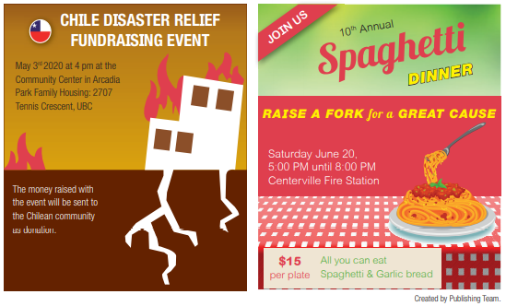
Adapted from Get Real textbook
Could you volunteer to participate in any of these events? Why? Why not?
Answers may vary

I would be part of Chile Disaster Relief. We never know when a catastrophe is happening, therefore supporting people who had suffered a significant lost is good.

