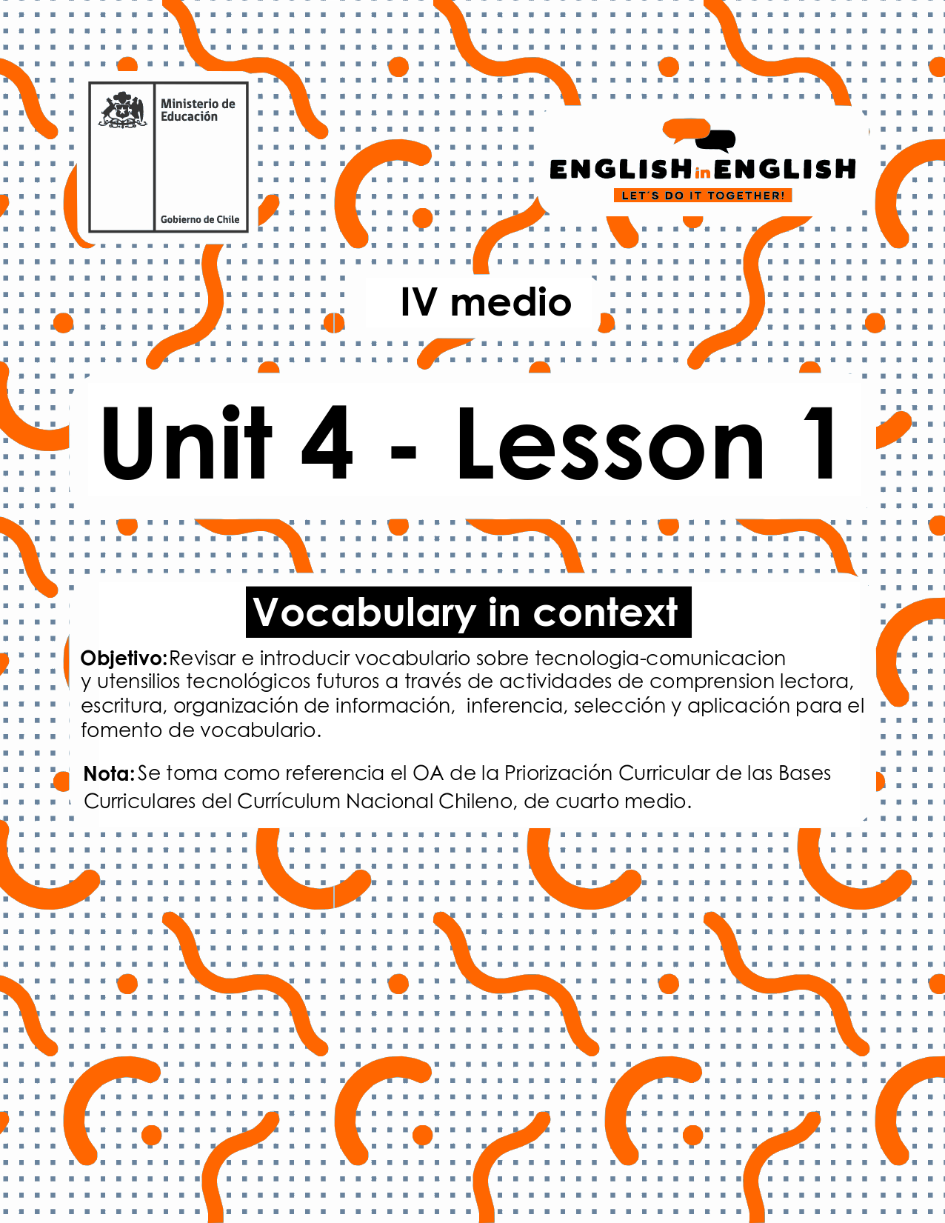

UNIT4
LESSON 1

ÚTILES

Texto del estudiante de 4° medio.
Diccionario de inglés.
Lápices.
Cuaderno de asignatura.

SECTION 1: SETTING THE CONTEXT

Hello Students, Welcome to unit 4!
In this unit we will work on the context of technology and its gadgets.
- Look at the following pictures with technological gadgets and answer the questions.
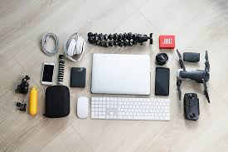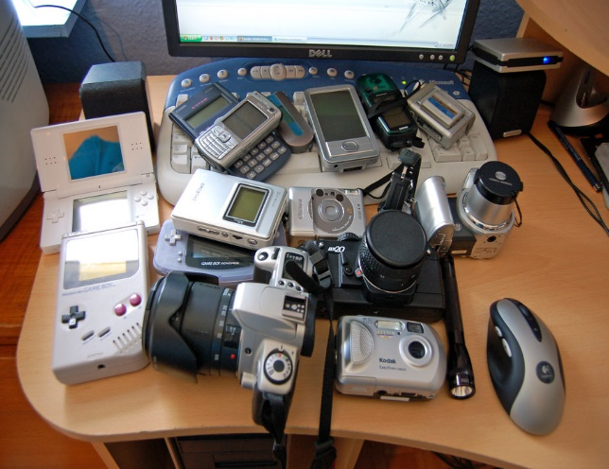
- Do you know what a gadget is?

- Can you name in English 5 gadgets from the photos?

- Do you have any gadget in your place? Which one is your favourite?

- What can you do with that gadget?

- The key features of a technological gadget are innovation, creativity and usefulness. Classify the following pictures into these categories. (Answers may vary).
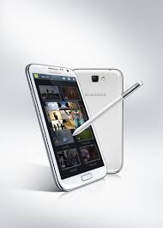Tablet | 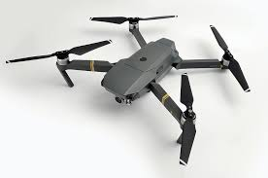Drone | 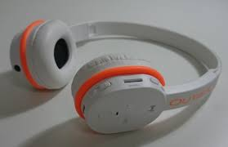Wireless headphones
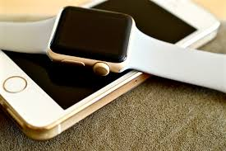Intelligent watch | 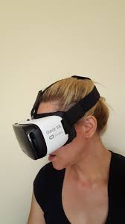Virtual reality lenses | 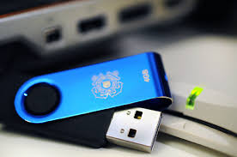  USB Flash Drive
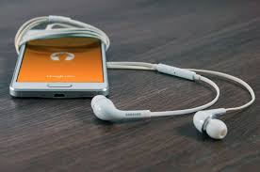Headphones | 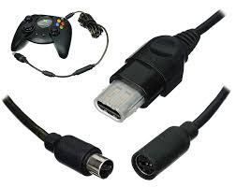Adaptors | 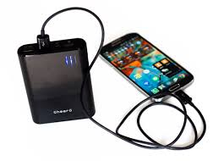  Power bank

Innovation | Creativity | Usefulness

SECTION 2: LET’S PRACTICE
- Have a look again at the gadgets from exercise 2 and fill in the blanks:

- ______________ It is an is an unmanned aircraft that can fly autonomously.
- _______________ A small data storage device used to move and store information from a computer.
- ______________It is a wearable computer in the form of a wristwatch.
- ______________A device used to connect several electrical appliances to a single mains socket.
- _______________ An electrical device consisting of two earphones held in position by a flexible metallic strap passing over the head.
- ______________A portable battery-powered device for charging the battery of a mobile phone or other electronic device.

4. Read the following myths about technology and state if they are True (T) or False (F) for you:

a.____ Technology will soon replace every human activity.
b.___ Leaving your phone plugged in might damages the battery.
c.____ You should always let your mobile battery completely die before recharging.
d.___ More megapixels will always mean a better camera.
e.___Cell phones might have the potential to cause cancer.

- Now, choose one true and one false statement for you. Then, complete the sentences:

- I think sentence __ is true because_______________________________________

- I think sentence __ is _______________________________________.

SECTION 3: LET´S CONSTRUCT AND APPLY OUR KNOWLEDGE

- For this first project of the unit, you will have to describe a gadget that you consider useful, innovative, and original. Loot at these kitchen gadgets for inspiration, and answer in the box below.
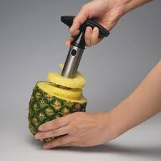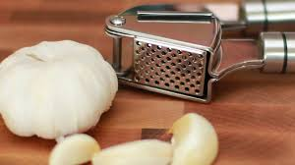

The gadget I consider original is ______________________________
This Gadget is also helpful as __________________but more importantly it is innovative as it ________________________________________________________

SECTION 4: Extra activity
Look around your house and write a gadget for the following consonants and vowels
Vowel | Gadget
F | Fax machine,
B | Battery
I | Iron
C
R
T

