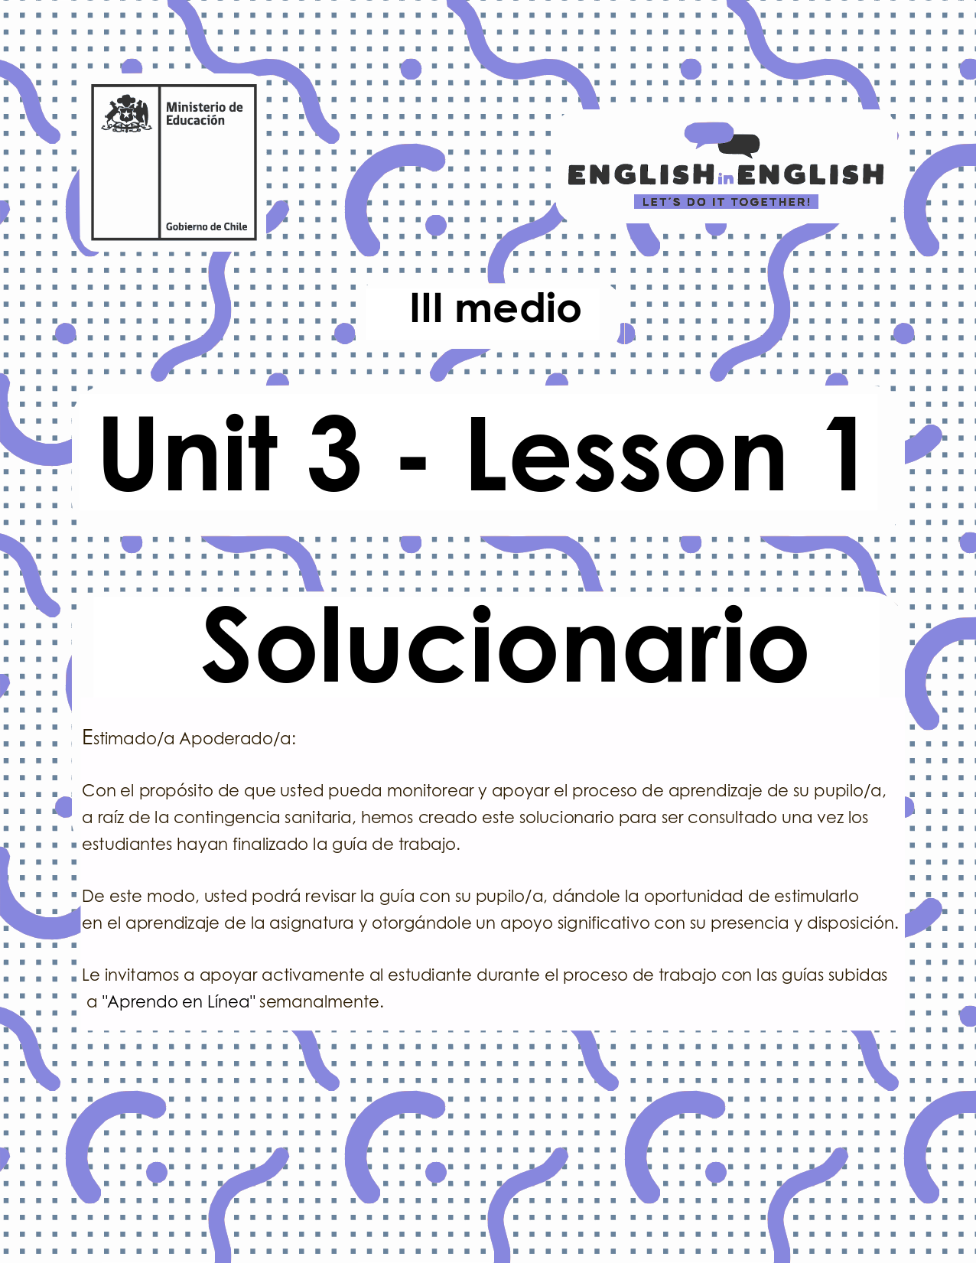

UNIDAD 3
LESSON 1

ÚTILES

- Texto del estudiante de 3° medio.
- Diccionario de inglés.
- Lápices.
- Cuaderno de asignatura.

ICONS FOR ACTIONS

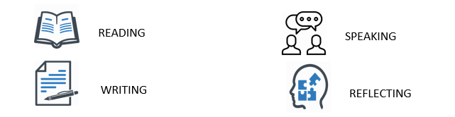

SECTION 1: SETTING THE CONTEXT:

Hello everyone! Welcome to unit number 3. In this unit we will cover the topic of good health by considering the current context.

- Look at the picture and answer the following questions.
- Which of the images in the picture reflect your lifestyle?
The avocadoes and bananas. The basketball images also reflect my lifestyle because I love sports.

- What would you add to the image to reflect a healthy lifestyle?
I would add a glass of natural fruit juice, and a bicycle.

- Do you have a healthy lifestyle? If so, can you tell us why/why not?
Yes, I do. I take walks and avoid eating junk food.
No, I do not. I do not like exercising or eating just fruit and vegetables.

- What about doing things like exercising, avoiding too much sugar or relaxing to feel good? Do you do any of these? Please explain.

Yes, I do. I try to stay healthy and strong.
No, I do not. I prefer enjoying without worrying about those too much.

- Many times, doctors and therapists have talked about the importance of taking care of ourselves by avoiding or promoting certain actions in daily life. Read the following words/phrases and classify them into the following chart:

Super foods – jogging – mindfulness – workout – daily treats - soreness – smoking – practice yoga – feeling stressed – always eat breakfast – sleeping well – avoid medical care- take morning walks – high calorie snacks - fun breaks – overthinking - salty food

Good health habits | Bad health habits
Super foods  Jogging - always eat breakfast  Mindfulness - sleeping well  Workout - take morning walks  Practice yoga- fun breaks | Smoking - salty food  feeling stressed – avoid medical care  high calorie snacks  soreness  overthinking

SECTION 2: LET´S PRACTICE

- Read the following text about superfoods and then complete the chart with the words from the box:
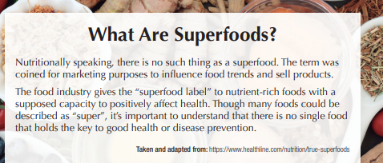
Increases flexibility - Chia - Good Sleeping - Beetroot - Brain fitness - Prevent soreness - Prevent stress - Seaweed - Diet

Superfood examples | Benefits for the body (Physical health) | Benefits for the mind (Mental health)
Chia | Diet | Good Sleeping
Beetroot | Prevent soreness | Prevent stress
Seaweed | Increases flexibility | Brain fitness

- Read the following statements and write if you “agree” (A) or disagree (D) according to your opinion:
(The students answers may vary)
A ___A___ Some of the benefits of practicing sports are feeling good and staying in shape.
B __A____ Some food like avocado, chia and pomegranate help to keep brain’s fitness.
C ___A___ Feeling stressed and anxious can affect your brain.
D ___D___ Life expectancy only depends on good sleep habits.
E ___D___ Having a diet just refers to eating fruit and vegetables.
F ___D___ Mindfulness and yoga are just for children or young people.

- How many “agree” or “disagree” statements did you subscribe? Do you agree with all of them? Choose 3 of them and complete the sentences:

- I agree with sentence __A_ because__sports help to keep my body and mind healthy.

- I disagree with sentence __D___because__it depends on the way someone takes care of themselves.

- I think sentence___C__ is right because___they can trigger dangerous physical and mental responses.

- Read Roberto´s description about his healthy habits over the COVID-19 pandemic and complete the missing vocabulary with words from this worksheet. Pay attention to the letter clue 😉.
Over the COVID-19 pandemic, I have made big efforts to keep a HEALTHY lifestyle. Every morning, I wake up at 8:00, I have breakfast, and I do EXERCISES to stretch my muscles and be FLEXIBLE. After that I have bread and milk for breakfast, and I always eat AVOCADO which is a super food. I care a lot about my DIET because this can prevent STRESS which is bad for my productivity. I additionally, SLEEP from 7 to 8 hours a day.

SECTION 3: LET´S CONSTRUCT AND APPLY OUR KNOWLEDGE
- Can you name some of the activities you are doing to keep a good mental health during the quarantine?
- I eat healthy and I do plenty of exercise to keep fit
- I try not to be connected the whole day on the computer, so I read and do some manual activities in my free time.
- I try to keep my normal routine with small adaptations. For example, I get up at 8:30 every morning and I shower, then at night I go to bed at 23:30.

- A healthy lifestyle has both short- and long-term health benefits. Can you list some of them? Use the vocabulary from the worksheet to help yourself.

Short term health benefit | Long term health benefit
For example:  - Better health makes you feel strong.  - You will improve your concentration and memory.  - You will increase your body´s resistance power. | For example:  - It helps you live longer.  - It will improve your strength and flexibility.  - It will boost your immune system.

