UNIT 2
LESSON 3

ÚTILES

- Texto del estudiante de 4° medio.
- Diccionario de inglés.
- Lápices.
- Cuaderno de asignatura.
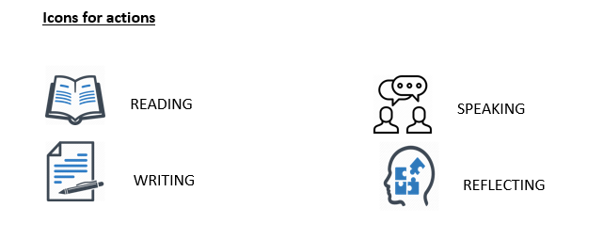

SECTION 1: SETTING THE CONTEXT

Welcome to lesson number 3! Now it’s time to practice some Writing skills! Let´s begin with the following exercises:

- Look at the following pictures and write the corresponding WH question.

Where is the supermarket? | WHAT Is that? | WHEN Is the meeting?
why are you so angry? How much money do you want?

- We use WH-questions to find out more information every time a question cannot be answered with “yes” or “no”.
- Complete the following dialogue with Wh-question from the box:

WHAT – HOW – WHICH – WHY- WHERE

Journalist: ___Which______ one is your family name?
Elena: It is Astudillo
Journalist: ___What______ do you do?
Elena: I am a painter.
Journalist: ___Where______ do you work?
Elena: At St Mary´s Art Gallery.
Journalist: __How_______ long have you work there?
Elena: For three years.
Journalist: ___Why_______do you work there?
Elena: Because it is my family´s business.
Journalist: Thanks Ms Astudillo! Please don´t forget to send me a short email telling more things about yourself as soon as possible. Goodbye!
Elena: Goodbye!

2.1 Later, Elena starts writing the email telling about herself.
- Read the information below and rewrite the sentences using the words in brackets.
- Use the underline ones as a clue.
- Do not forget to pay attention to tenses:

Well, I have always believed arts is in my blood. Instead of playing with friends or watching cartoons, since I was a little girl, I started spending long hours drawing, painting or doing whatever possible to express my feelings and emotions trough songs, textures or colours. During school time, it was very difficult for me to concentrate on Maths or Chemistry lessons as the only thing I wanted to do was use palettes, clay or crayons. Art classes were a blast! I cannot say the same for History or ICT lessons. As years went by, I told my parents I wanted to dedicate my life to arts. Since that day, mom and dad are my biggest fans!

- Since she was a child, Elena has always devoted her life making art projects. (enjoy)
Helena has always enjoyed making art projects.
- At school, it was hard for her to attend lessons like Math or Chemistry. (can´t stand)
Elena couldn´t stand Math and Chemistry lessons at school.
- Attending art classes made her very happy. (love)
Elena loved attending art classes.
- Elena´s parents agree with what she does for a living. (like)
Elena´s parents like what she does for a living.
SECTION 2: LET’S PRACTICE!
- Look at the following collage and complete the sentences with your personal preferences about art.
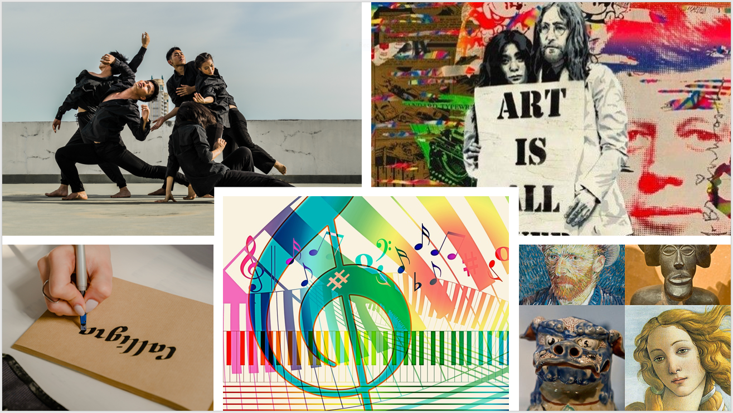
- I love __MUSIC__________
- I hate__DANCING__________
- I enjoy__PAINTING_______
- I like _ARTS_________
- I don`t Like _CALLIGRAPHY____

4. Complete the concept map with your ideas about art.
- Then, complete a text message explaining why you like art or not.

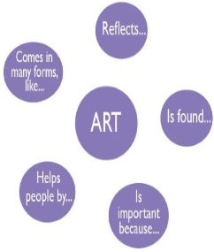
(SUGGESTED ANSWERS)
From:
To:
Hello __PETER__! I hope you are ok. I am writing to tell you about arts. Well, for me art reflects EMOTIONS _. Art is everywhere. For example, Art is found IN BOOKS, TV, STREETS_. Art is important because IT HELPS TO RELEASE HIDDEN EMOTIONS_, and Art also helps people by _SUPPORTING THEIR SPIRITS_. In conclusion, Art comes in many forms, like VISUAL, WRITTEN AND ORAL__.
That’s all,
Bye_YNDRA__

SECTION 3: LET´S CONSTRUCT AND APPLY OUR KNOWLEDGE

5. Let´s check your general knowledge about graffiti and street art now!
- Read the following Biography and look at these famous graffiti from the iconic and incognito artist Bansky from England.
- Then answer the questions below:

Banksy is an anonymous England-based street artist, political activist, and film director. His satirical street art and subversive epigrams combine dark humor with graffiti executed in a distinctive stencilling technique. His works of political and social commentary have been featured on streets, walls and bridges throughout the world. Banksy's work is sensitive and shows a combination of feelings that convey irony, love, poverty, passion and reality. In these two graffiti we can see an adaptation of the girl with a pearl earring wearing a surgical mask, and a little girl leaving her balloon shaped heart away.
Adapted from https://es.wikipedia.org/wiki/Banksy

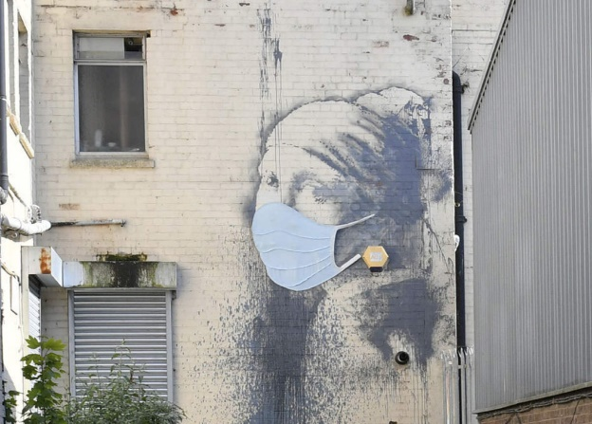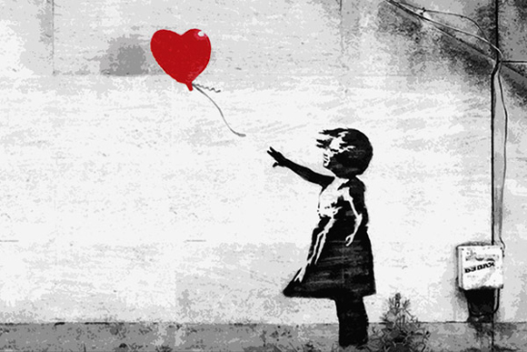

- What is happening in these pieces of street art?
- A girl is wearing a face mask/A girl lost her love/balloon
- How do they make you feel?
- Intrigued, worried, angry. Any feeling would be ok.
- Which of these pieces of street art is your favourite?
- The first one/second one

- Why?
- Any reason would be suitable, but the answer should include “because...”
- Where could you find this type of graffiti or street art in your city?
- In the streets/downtown/on the walls/everywhere

6. Now we would like to know about your city or community.
- Is there a piece of street art that you would like to tell us about?
- For example, the big graffiti and open sky museum in Valparaíso, or the Gabriela Mistral murals in Vicuña.
- Choose one piece of graffiti or street art from your city or community and tell us:

- The name (if you know it)
- Where it is
- What is happening in the art piece?
- What makes you feel
- Why you chose it
- Put a photo if you have one!

6.1 Write a short paragraph with the information.
- You can follow the text from Bansky Biography as an example.
Ideally, the paragraph should include the information requested above, and should be about any form of artistic expression within their community, although it is expected to be about street art or graffiti. The information can be also extracted from the previous activities.

SECTION 4: EXTRA ACTIVITY

7. It is time you use all your creativity!
- What about designing or making your own art manifestation?
- What would you do?
- What for?
- What kind of materials would you use?
- Tell us about it!
- You can start writing following this example:

You can start writing following this example:
I think I would make a sculpture related to my neighbourhood background. I love history and observing local traditions. I have always liked my community and the way my neighbours have faced difficulties and bad times. Although everybody here enjoys celebrating good news; nobody can´t stand abuses or mistreats. So, the name of my piece of art would be “4people- 2people.”
About materials, I would work with stones and wood because most houses here have been built with them and...

It may be fun to use my favourite materials. I think this might be a great project as I may ask for some opinions related to design and colours. I think this project might take almost a year, but I am sure everybody will love it!

