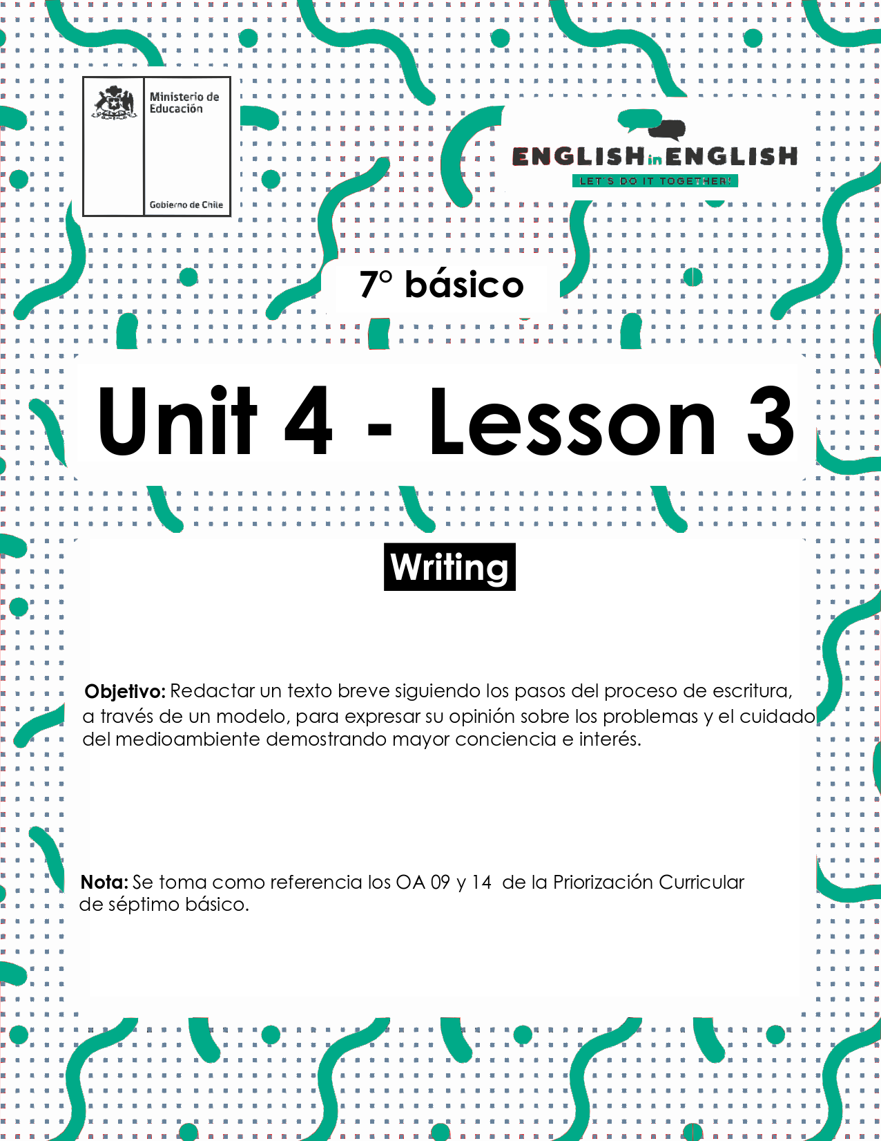
UNIT 4
LESSON 3

ÚTILES RECOMENDADOS:
- Texto del estudiante 7° básico.
- Cuaderno de inglés o 2 hojas en blanco.
- Lápiz grafito y goma.
- Diccionario de Inglés físico / online https://dictionary.cambridge.org/es/diccionario/espanol-ingles/

SECTION 1: SETTING THE CONTEXT
Reduce, reuse and recycle

1. Observe the images and answer.
- Observa las imágenes y responde.
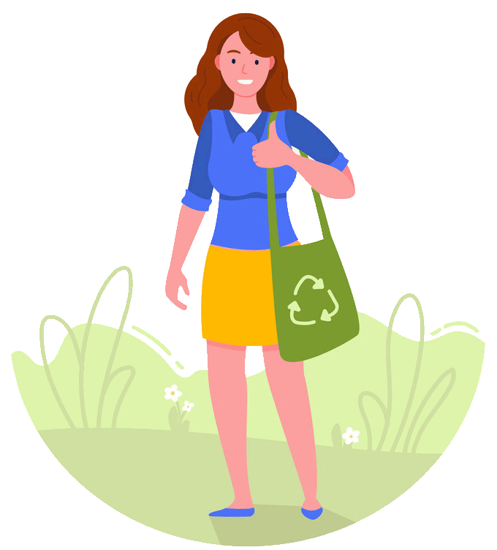
 | 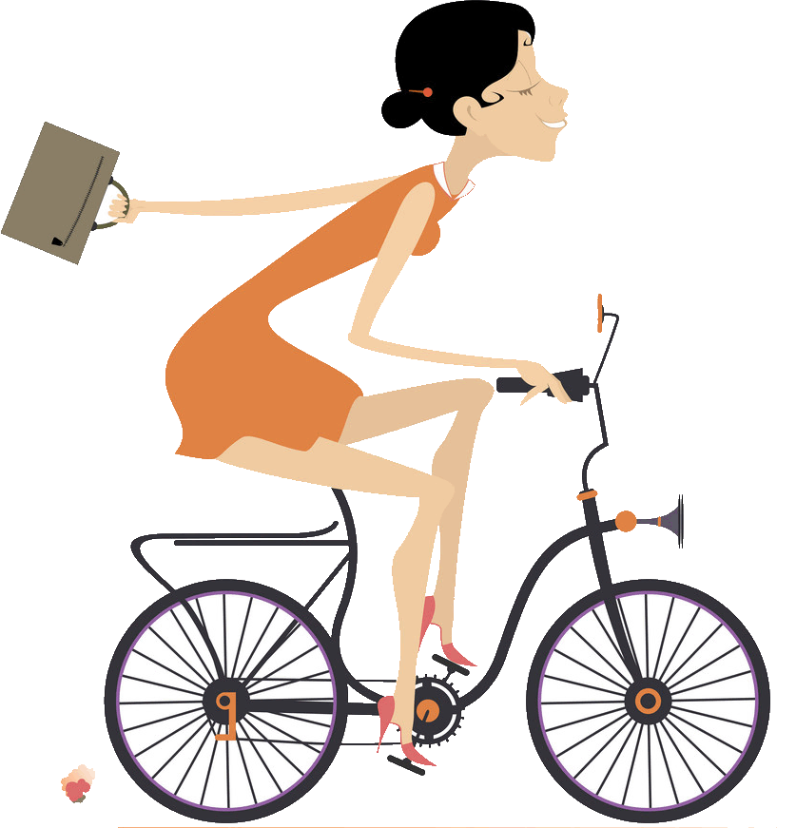 | 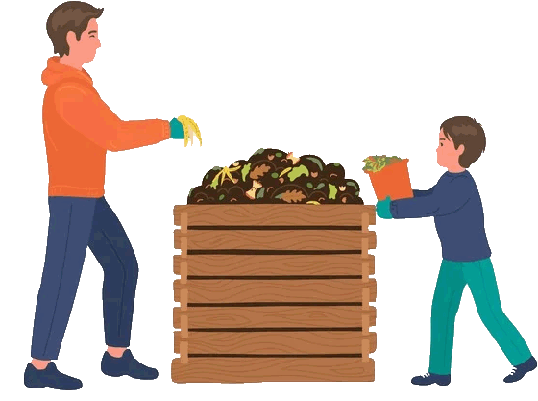

1. What are the people doing?
………………………………………………………
2. Do you think these activities can be done at home?
……………………………………………………….
3. What concepts do you relate these activities with?
………………………………………………………

2. How many activities can you identify? Write them.
- ¿Cuántas actividades puedes identificar? Escríbelas.
Use cloth bags - replace regular light bulbs -
set up a compost container -
grow an organic garden - reduce the carbon footprint -
reuse clothing

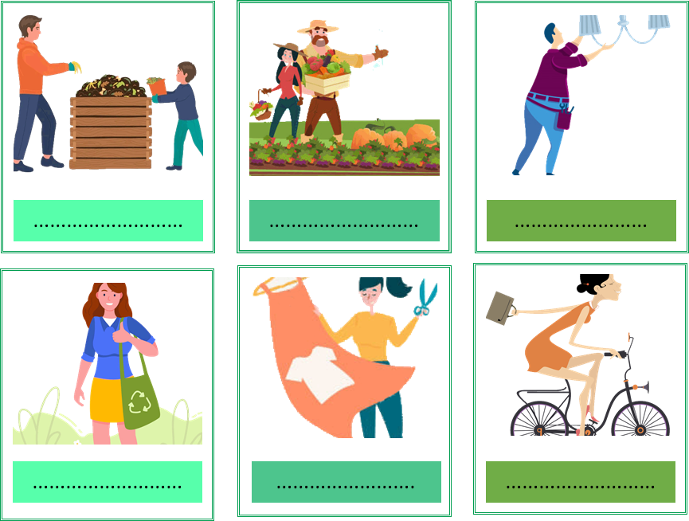

3. What do you do to reduce your carbon footprint? Complete the organizer with activities you do at school and at home.
- ¿Qué haces para reducir tu huella de carbono? Completa el organizador con actividades que haces en el colegio y en tu casa.
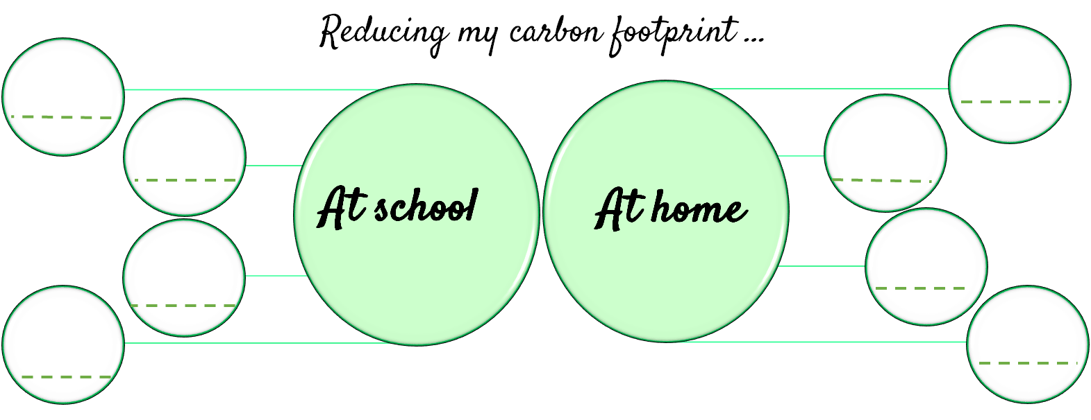

4. Read the following sentences and complete them with should or shouldn't.
- Lee las siguientes oraciones y complétalas con should o shouldn't
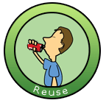
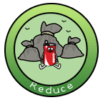
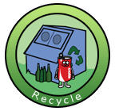
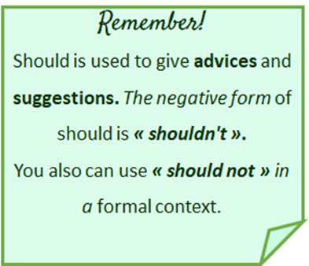

- You ………. buy toxic products whenever possible. Many toxic products such as motor oil and pesticides cannot be reused.
- You …….…. find safer alternatives to hazardous household products.
- You ……….. buy items that you won´t use. Buy only what you need.
- You ………. donate old clothes and books. Other people can reuse your unwanted clothes and books when you donate them to charity shops.
- You ………… build a Compost Bin. You can reuse many waste items, such as eggshells and old tea bags, using a compost bin.

SECTION 2: LET'S PRACTICE
Protecting the Earth at home
1. Before reading the text, answer the questions.
- Antes de leer el texto, responde las preguntas.
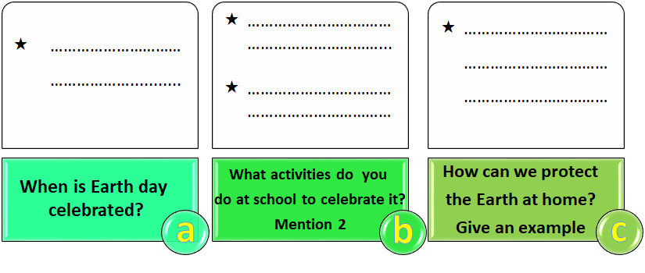

2. Read the text.
- Lee el texto.

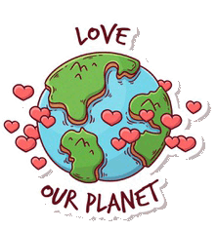
How to protect the Earth at Home
Take a realistic approach to protecting the earth and first consider what you can do in your own home. This is much more manageable than taking on the world. It is in simple everyday steps that you can make an impact.

Make your own non-toxic cleaning products. Doing this will reduce the use of you are reusing plastic containers. The ingredients are also biodegradable which means it is gentler on the environment.

Use cloth bags at the grocery store and when you are shopping, instead of using plastic bags. You reduce the use of plastic.

Explore the idea of purchasing energy-efficient appliances. Replace regular light bulbs with their energy efficient versions. They may cost a little more, but they last longer and use less energy.

Set up a compost container. All plant-derived foods, coffee grounds and tea leaves can be composted. You can have a small can in your kitchen and when it gets full, transfer the waste to an outdoor container. You can use the resulting rich fertile soil in the garden. It reduces the amount of garbage.

Grow an organic garden. If you have space or time to grow a garden, shop locally and support local farmers.

Reduce the use of car travel. Consider walking, carpooling and bike riding to get to where you want to go. If you have a car, keep it in good conditions, to reduce pollution.

Reuse clothing. Shop resale shops, garage sales and pass clothing items on to friends and family. Consider doing this with toys too and other house items. This helps to recycle and reduce trash.

Text taken from: https://en.islcollective.com/english-esl-worksheets/vocabulary/environment?page=4

3. Read the text and complete the sentences.
- Lee el texto y completa las oraciones.
- Non-toxic cleaning products will reduce the use of ……………….

- Use cloth ………… when shopping.

- Energy efficient light bulbs use less ……….

- To reduce ……………… consider walking, carpooling or bike riding.

- You can transfer your kitchen waste to an outdoor ……………..

- To protect the Earth, first you have to consider things you can do on your own ………….

4. Complete the diagrams with information from the text.
- Completa los diagramas con información del texto.
Reduce | - pollution

Reuse

Recycle

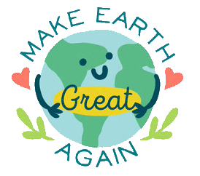
SECTION 3: LET´S CONSTRUCT AND APPLY OUR KNOWLEDGE
Reducing my carbon footprint
- Answer the questions.
  - Responde las preguntas.

Questions | Answers
Name at least 3 things you do to protect the Earth - according to the text “How to protect the Earth at Home”
Write in 3 words how we can protect the planet. (3“R’s”)
Do you know what the carbon footprint is?
Write your own definition for it.
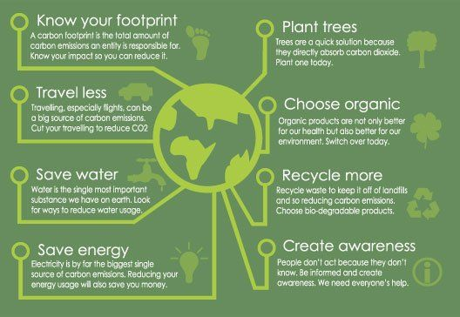

- Calculate your own carbon footprint, choose the answer.
- Calcula tu propia huella de carbono, elige la respuesta.

- How do you get to school?
- Walk or ride your bike
- Motorcycle
- Car
- Bus or van
- What kind of food does your family eat?
- Home cooked food
- Fast food
- What type of food does your family mostly eat?
- Vegetable/Fruits
- Bread
- Meat
- How many carbonated drinks (soda or pop) do you drink?
- None
- I can per day
- 2 can per day
- 3 or more cans per day
- Do you turn off the water when brushing your teeth?
- Yes
- No
- How often does your family do laundry?
- Once per month
- Twice per month
- Once per week
- Twice or more per week
- Do you turn the lights off when not needed?
- Yes
- No
- Do you turn off your computer, video games or other electronics when you are not using them?
- Yes
- No
- What type of fuel or energy is used to heat your home?
- Wood
- Propane
- Oil
- Natural gas
- Does anyone in your home own any of the following items? Circle all that apply.
- TV
- Cell phone
- Computer
- Washing machine
- Video Game
- Refrigerator
- Microwave
- Electric kettle

SCORING INSTRUCTIONS:
For questions 1through 9: 1 point for A / 2 points for B / 3 points for C / 4 points for D
For question 12: 1 point for each item circled.
Add the points and determine your “carbon footprint”

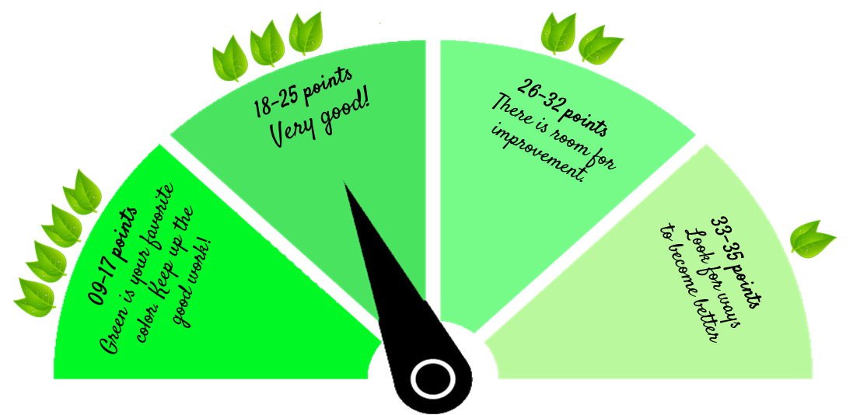

- Review your choices in the survey (activity nº2) and using the tips given in the text “How to protect the Earth at Home”, write your plan to reduce your carbon footprint.
- Revisa tus respuestas en la encuesta (actividad nº2) y usando los tips dados en el texto “How to protect the Earth at Home”, escribe tu plan para reducir tu huella de carbono.

Consider the following aspects to write your paragraph
What things will you turn off? - How will you get to school? - What will you eat? - How much electronics will you use? - What will you recycle? - Will you reduce the use of plastics? - What will you reuse?
What changes can you make in your life to reduce your carbon footprint?
To reduce my carbon footprint I will______________________________
_________________________________________________________________
_________________________________________________________________
_________________________________________________________________
Try to make some of these changes during the next week...

SECTION 4: EXTRA ACTIVITY
Solve the word search
1. According to the topic of this lesson, find the following words in the word search. They can be in any directions.
- De acuerdo al tema de esta lección, encuentra las siguientes palabras en la sopa de letras. Ellas pueden estar en cualquier dirección.

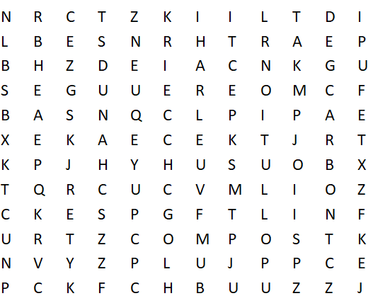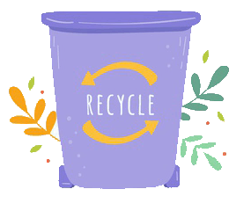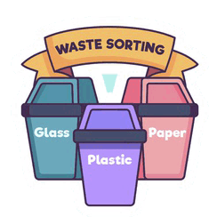 | Words  - carbon  - compost  - earth  - footprint  - pollution  - recycle  - reduce  - reuse

SECTION 5:
Digital Resources
Take a look at these links!

- https://bdescolar.mineduc.cl/info/cleaning-up-the-earth-00046337
- https://learnenglishkids.britishcouncil.org/word-games/environment
- https://www.nationalgeographic.org/education/
- https://www.nationalgeographic.org/education/resource-library/?q=&page=1&per_page=25&subjects=Conservation
- https://kids.britannica.com/kids/article/environment/399445
- http://www.recycling-guide.org.uk/
- https://bdescolar.mineduc.cl/info/recycling-earths-resources-00046329

NO OLVIDAR REPASAR EL CONTENIDO CON UN ADULTO

