UNIT 3

LESSON 4
Unidad: What´s on
Curso: Cuarto medio
Objetivo: Aplicar y revisar contenidos previos relacionados con los reality shows y la publicidad, a través de actividades de comprensión lectora, etiquetado de imágenes, llenado de información y construcción para la creación de un programa artístico semanal para un reality show.
Nota: Este objetivo está basado en los Objetivos de Aprendizaje priorizados del Programa de Estudio de 4° Medio.

ÚTILES

- Texto del estudiante de 4° medio.
- Diccionario de inglés.
- Lápices.
- Cuaderno de asignatura.

GUÍA PARA USAR EL SOLUCIONARIO

- ¿Qué es un solucionario?
- Un solucionario incluye las respuestas a todas las preguntas y actividades.
- Algunas de las preguntas tienen más de una posible respuesta.
- Algunas de las preguntas tienen una sola respuesta.

- ¿Cómo revisar mis respuestas?
- Encontrarás títulos en los encabezados de los ejercicios que dicen “answers” en respuestas cerradas, y en el caso de respuestas abiertas encontraras un encabezado indicando “answers may vary”.

- Las respuestas en ejercicios de verdadero falso, llenado de tablas, unión de letras y dibujos, etc. pueden estar en:
- Negrita
- Subrayado
- Sombreado con colores de formato de guía (purpura, verde, naranjo)
- Encerradas en círculos
red
- Destacadas
- Tachadas

- Ejemplos de respuestas se ilustran a continuación:
I) What is the first thing you think of when you look at it? Why?
Answers may vary.
Example: Art, music, painting. Because there are different people doing these activities.

II) Find the words to complete the sentences using the picture clues. For extra help you can use the Pictionary at the end.

a. The artists used materials like rubber, plaster and styrofoam to make their art.
b. Pomaire pottery is mainly made of clay. Don´t forget to visit this magical village!

LESSON 4

REVIEW

SECTION 1: SETTING THE CONTEXT

Hello students! Welcome back to lesson 3! In this lesson we will be reviewing the contents from this lesson and previous units.

- Look at the pictures and answer these questions
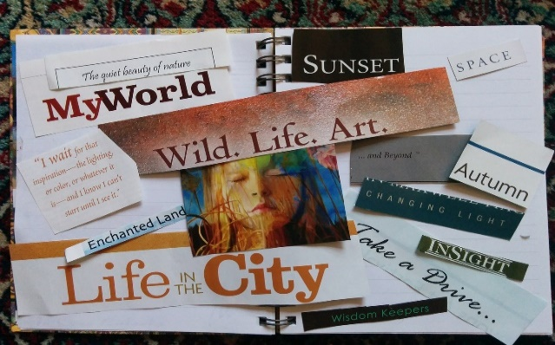

- Can you name the social media websites from the image?
Answers may vary.
Twitter, Instagram, Facebook, Snapchat, Camino, Tumblr.

- Can you name different types of artistic manifestations?
Answers may vary.
Dancing, painting, calligraphy, graffiti, opera,

- Can you describe one distinctive aspect of your generation?
Answers may vary.
Active and environmentally aware

- Can you write the days of the week?
Answers may vary.
Monday, Tuesday, Wednesday, Thursday, Friday (Saturday and Sunday)

- Can you write 5 different music genres?
Answers may vary.
Rap, Reggae, Folk, Cumbia, Salsa

- Can you write 3 plays from theater?
Answers may vary.
La Negra Ester, Waiting for Godot, Romeo and Juliet

- Can you name 3 well-known Chilean movies?
Answers may vary.
Machuca, Una Mujer Fantástica, La Nana
(Source: original activity)

- The Fringe festival in Edinburgh is the biggest Performing arts festival in the world. Every August artists from all over the world go to Edinburgh to perform their talents. Look at the following pictures and label them.

Edinburgh – pantomime – cinema – graffiti – weekly calendar – dance – theater – street artists - acrobatic- stand-up comedy
Answers
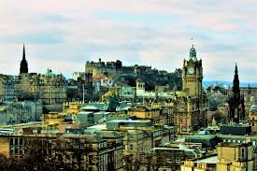
Edinburgh | Cinema
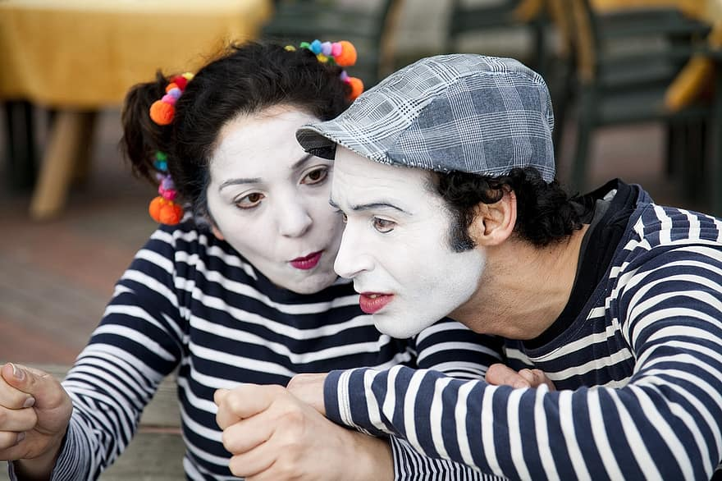 | 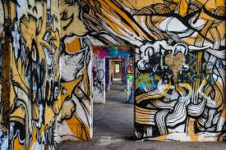
Pantomime | Grafitti
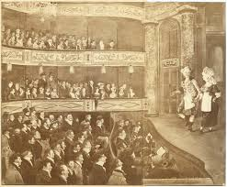 | 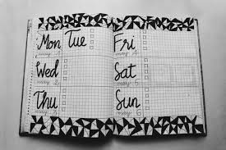
Theater | Weekly calendar
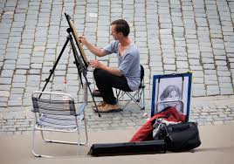
Street artist | Dance
Acrobatic | Stand-up comedy
(Source: original activity)

SECTION 2: LET´S PRACTICE

- Participating in TV programs can be a great chance of changing someone's life for different reasons and purposes. Read the following texts.
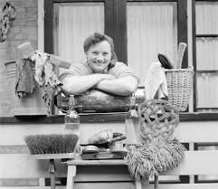 | a. Ann, a housewife says “I need money to buy a new house for my family. I do not have a college degree so winning this TV show could help me to get money easily and in a short period of time. I have been doing some exercise and dieting to be ready for any physical contest. I will miss my kids a lot, but the sacrifice is worth it.”

b. Bell, a journalist says “I have applied to many TV channels and radios, but I have not been able to get a job. I am sure if I get into de program, I will get the job of my dreams! I want to be known by people and win an Emmy Award before I am 30 years old.”

c. Phill, a plumber says “I love television, so I decided to participate at a reality show to have the experience of a lifetime. I do not care if I must take part in dangerous contests or give up thinks like hot water or clean clothes. My goal is to get money and fame at any price!

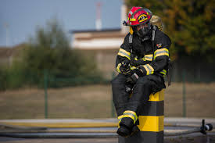 | d. Jim, a firefighter says “I love helping people, and right now my community needs a new equipment for our Fire station. If I win the TV program, I will be able to buy what we need and to start a campaign to enroll more volunteers. I am just keeping all my fingers crossed!  (Source: original texts)

- Read and tick the correct statement according to the texts
Answers
Who wants to...? | Ann | Bell | Phill | Jim
win an international prize? |  | x
make a dream come true? | x | x | x | x
get money fast? | x
buy new equipment to help the community? |  |  |  | x
help his/her family? | x

- Are you for or against the reasons given by Ann, Bell, Phill and Jim about applying and participating in the TV show? Complete two sentences.
Answers may vary

- I am for ____Jim______ ´reasons because he wants to help others more than himself.
b. I am against ___Phill_____´reasons because he only wants money and fame and do not care about helping others with the TV program´s prize.
- Answer the following questions based on the information from activity 3:

- Do you think money is a valid reason to enter a reality show? Why/Why not?
Answers may vary.
Yes, I do. Participating is a job so people can make good money if they win.
No, I do not. Money cannot buy things like happiness, fraternity or generosity
- Do you think that people who enter reality shows are role models for their community? Why/Why not?
Answers may vary.
Yes, I do. They can be good leaders specially for young people.
No, I do not. Participants only want to win, get money and become famous. They do not care about being someone known by their moral values

- Would you support your parents if they wanted to enter a reality show? Would it be embarrassing? Why/Why not?
Answers may vary.
Yes, I would. It would be nice to see my parents fighting to get their objectives.
No, I would not. It would be embarrassing if audiences knew everything about our private lives.

- Do you think that participating in a reality show would help you to get your dream job? Why/Why not?
Answers may vary.
Yes, I do. Especially If I win. That way I would get everything I want!
No, I do not. I want to be known for my intelligence and values, not for participating at a TV show.

SECTION 3: LET´S CONSTRUCT AND APPLY YOUR KNOWLEDGE

- Congratulations!!! You are one of the finalists to win the reality show “YOUR BEST WEEK”. Our judges will pay special attention to your final performance, therefore, be interesting, creative, original and coherent in your ideas.
For the first challenge you must create a visual representation of your generation focusing on the uses you give to social media on a WEEK.

For this, follow these steps:

- First, describe your favorite social media and explain your choice.
Answers may vary.
My favorite social media platform is Instagram. Although it has changed throughout the years, ranging from Facebook to Twitter, Instagram is always what I end up coming back to in the end. I like the art features of this App, but I really love to see pictures from my friends.
Answer
Adapted from https://www.quora.com/What-is-your-favorite-social-media-platform-Why
- Then, describe the social media use for Monday, Tuesday, Wednesday and so on.
- Finally, describe how this social media relates to your generation.
Answers may vary.
I think that the social media from my generation is Instagram and TikTok, both are just amazing as we can express our feelings and arts without limits.

Template for social media use over a week:
Answers may vary
Social media | Monday | Tuesday | Wednesday | Thursday | Friday
Morning | TikTok  Instagram | Instagram  Twitter | Instagram  Snapchat | Twitter  Snapchat | TikTok  Twitter
Evening | Instagram  Twitter | TikTok  Instagram | Twitter  Snapchat | TikTok  Twitter | Instagram  Twitter

- For the second and last challenge, you must be very creative and original because this is about your ART manifestation. Therefore,

- First, think about a WHOLE WEEK of arts just for you...
- Then complete the template with art manifestations.
- Create a poster to promote your WEEK of ARTS as if it were a festival.

Template for your week of art manifestations:
Answers may vary
Events | Monday | Tuesday | Wednesday | Thursday | Friday
Morning | Dance  Graffiti | Body painting | Cinema  Opera | Pantomime a cappella | Painting  Cinema
Evening | Pantomime  Cinema | Calligraphy pantomime | Dance  A cappella | Theater  A cappella | Theater  Calligraphy

EXTRA ACTIVITY:

Do you remember your favourite reality show or TV show? Please write down the reason(s) why you liked it so much. Do not forget to include the name, location, setting(s), participants and requirements related to that TV show.
Answers may vary.
I liked “Master chef 1” a lot because I love cooking and discovering new recipes. On that reality show, ordinary people who liked cooking very much had to create new dishes or prepare what the chefs told them to do. The program was recorded at a special kitchen that had all the necessary things and appliances to cook. Every night from Monday to Friday participants competed against each other to get the first place. The program was broadcasted almost four months

.

