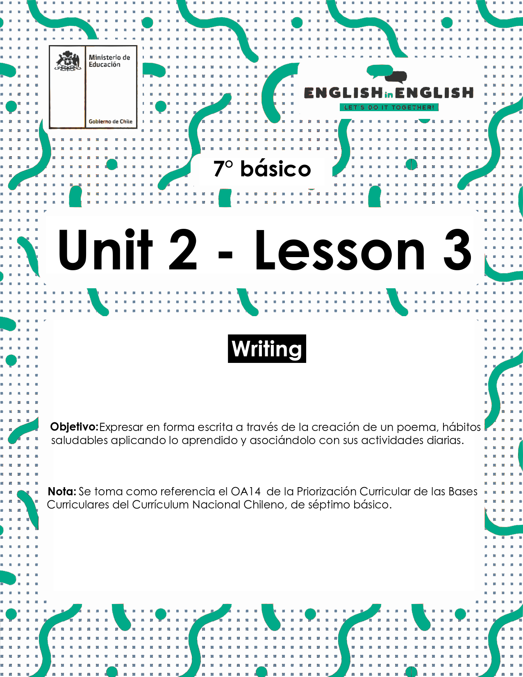
UNIT 2
LESSON 3

ÚTILES RECOMENDADOS:
- Texto del estudiante 7° básico.
- Cuaderno de inglés o 2 hojas en blanco.
- Lápiz grafito y goma.
- Diccionario de Inglés físico / online https://dictionary.cambridge.org/es/diccionario/espanol-ingles/

SECTION 1: SETTING THE CONTEXT

Healthy Habits

1. Observe the image and answer the questions.
- Observa la imagen y responde las preguntas.
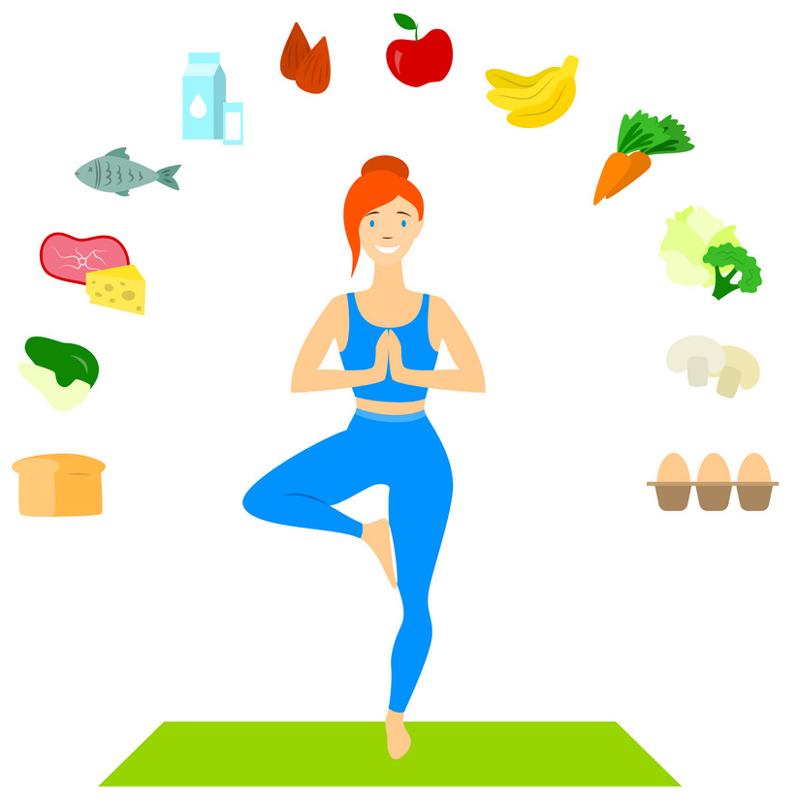

Questions | Answers
Do you think the girl is a healthy person? Why?
What food items can you identify? Write at least 4.
What kind of physical activities do you think the girl does?

2. You will identify 4 healthy habits recommendations, observe the images, and match them. Write the recommendation in the space given.
- Identificarás 4 recomendaciones con hábitos saludables, observa las imágenes y relaciónalas. Escribe la recomendación en el espacio dado.

A) You must eat fruits. B) You should do physical activity.
C) Don´t smoke. D) You should drink 2 liters of water.

 | 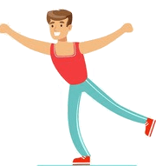 | 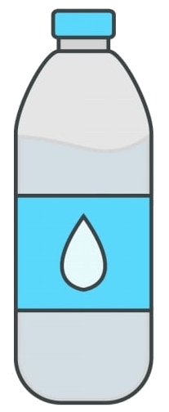 | 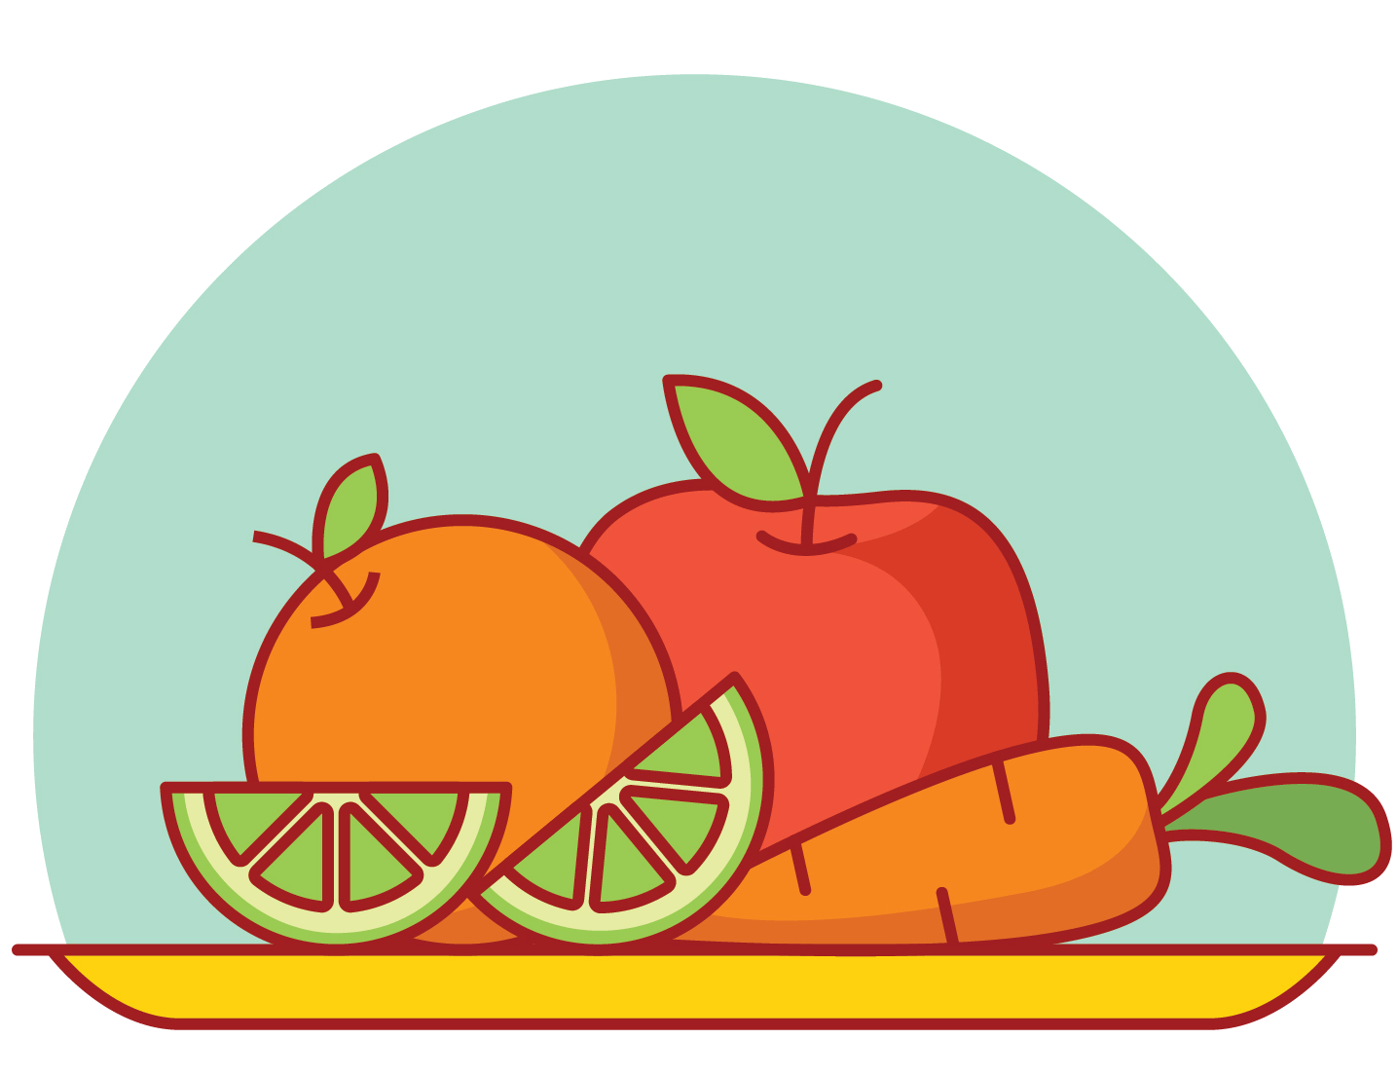

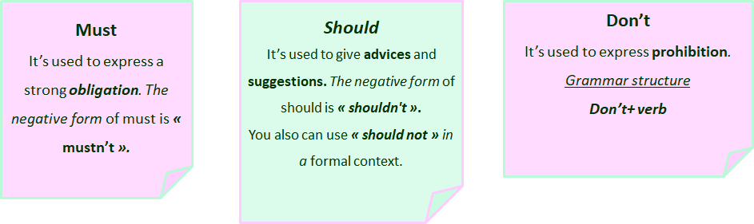

3. Answer these questions according to the previous activity. Write the corresponding letter.
- Responde estas preguntas según la actividad previa. Escribe la letra correspondiente.
A) You must eat fruits. B) You should do physical activity. C) Don´t smoke.
D) You should drink 2 liters of water.
- Which instruction expresses obligation? ______
- Which instruction expresses prohibition? ______
- Which instruction expresses suggestion? ______

4. Answer these questions about you.
- Responde estas preguntas acerca de ti.
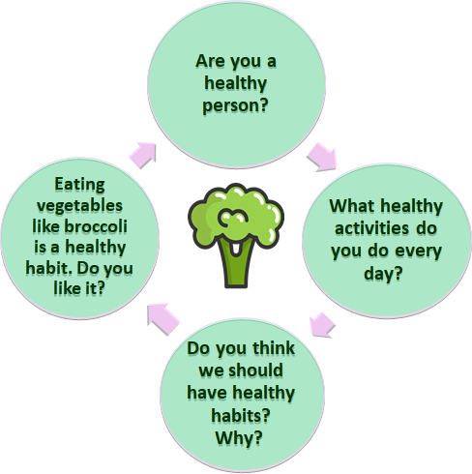

SECTION 2: LET´S PRACTICE

Poem
- Read the poem and underline the words you don´t know. Look them up in the dictionary.
- Lee el poema y subraya las palabras que no conoces. Búscalas en el diccionario.

My favorite food is broccoli.
I eat it every day.
There isn’t any other food
that makes me feel this way.
It makes me feel so healthy.
It makes me look so cute.
But, mostly, I like broccoli
because it makes me more astute.
Poem adapted and taken from https://www.poetry4kids.com/poems/my-favorite-food-is-broccoli/

2. Read the poem again and write a title for it.
- Lee el poema nuevamente y escribe un título para este.
“ ”

3. Find in the poem words that rhyme. Example: day - way
- Encuentra en el poema palabras que rimen. Ejemplo: day - way
_______________________________________________

4. Write a new stanza of 4 lines for the poem in the space given.
- Escribe una nueva estrofa de 4 versos para el poema en el espacio dado.

My favorite food is broccoli.
I eat it every day.
There isn’t any other food
that makes me feel this way.
It makes me feel so healthy.
It makes me look so cute.
But, mostly, I like broccoli
because it makes me more astute.
………………………………………..
…………………………………...…
………………………………………..
……………………………………..…

SECTION 3: LET´S CONSTRUCT AND APPLY OUR KNOWLEDGE

Suggestions and obligations for a healthy lifestyle

1. Read the sentences expressing obligation and suggestion and correct them. Use words from the box to help you.
- Lee las oraciones que expresan obligación y sugerencia y corrígelas. Usa palabras del cuadro para ayudarte.
should shouldn´t must mustn´t

a) You shouldn't do physical exercise.
Example: You should do physical exercise.
b) You must drink sodas.
___________________________________________
c) You mustn't eat fruits.
___________________________________________
d) You should eat pizza every day.
___________________________________________
e) You should use your cellphone for long hours each day.
___________________________________________
f) You mustn´t respect other people.
___________________________________________

2. Write 5 sentences about habits a friend must have a healthy lifestyle. Complete them in the chart.
- Escribe 5 oraciones con hábitos que un amigo debe tener para un estilo de vida saludable. Escríbelos en el cuadro.

Example : You must eat fruits and vegetables every day.

1.________________________________________________________________
2.________________________________________________________________
3_________________________________________________________________
4_________________________________________________________________
5_________________________________________________________________

3. Write 5 sentences about habits a friend mustn’t have a healthy lifestyle. Write them in the chart.
- Escribe 5 oraciones con hábitos que un amigo no debe tener en un estilo de vida saludable. Escríbelos en el cuadro.

Example : You mustn't eat junk food.

1.________________________________________________________________
2.________________________________________________________________
3_________________________________________________________________
4_________________________________________________________________
5_________________________________________________________________

4. Write your own poem giving suggestions for having a healthy lifestyle. You can choose your favorite food item or your favorite physical activity. Include images and help you with all the previous activities.
- Escribe tu propio poema dando sugerencias para tener un estilo de vida saludable. Puedes elegir tu alimento favorito o tu actividad física favorita. Incluye imágenes y ayúdate con todas las actividades previas.

title :
……………………………
……………………………………………..
………………………………………………………
……………………………………………..
……………………………………………………..
…………………………………………………..
……………………………………………………………..
………………………………………………………………..
………………………………………………………
………………………………….
Written by……………….

SECTION 4: EXTRA ACTIVITY

My poster
Create a poster about “Healthy habits” to encourage your family and friends to be healthy. Follow these steps:
- Use images to express your ideas
- Write a title
- Express “Suggestions”, “Obligations” or “Prohibitions” in your poster
- Use vocabulary related to food and physical activities
Examples:
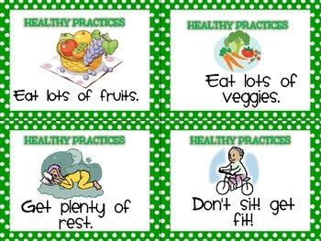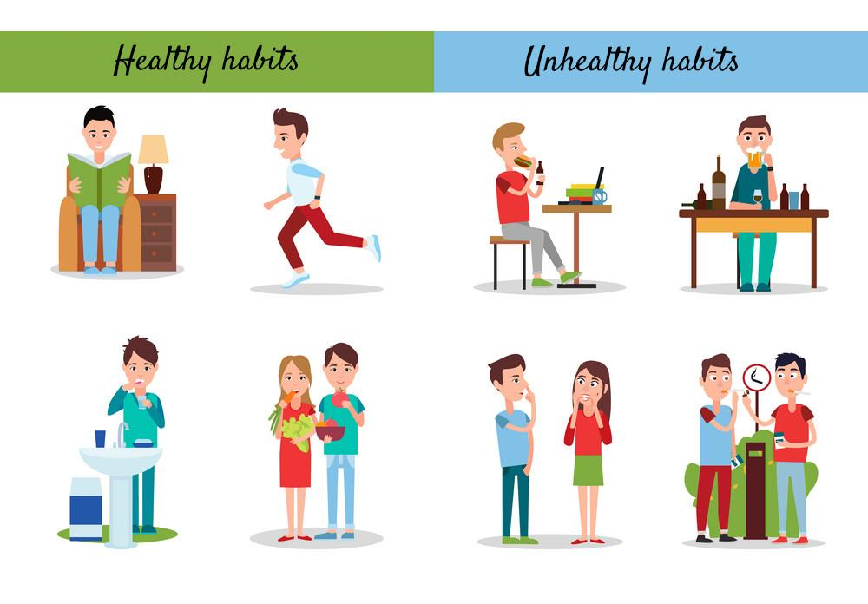

- It has a message.
- It has a creative way to present the information.
- It has colors.
- It has the precise information.
Share it with your friends through social media and eodp_chile / Students in Action.

SECTION 5: DIGITAL RESOURCES
Take a look at these links!

In addition, there are several online rhyming dictionaries. Here are a couple of the best:
- Online Rhyming Dictionary https://www.poetry4kids.com/
- RhymeZone Online Rhyming Dictionary https://www.rhymezone.com/

NO OLVIDAR REPASAR EL CONTENIDO CON UN ADULTO

